# CHAPTER 1 INTRODUCTION

# PROBLEM DEFINITION

# Event Management system is mainly used to manage all the activity related to an event. In Any event many service providers manage to work simultaneously and it is very hard to manage these providers and it is also very important for the event organizers to have the contact details of these service providers so that he can contact them at any time to plan an event. YouParty_WeOrganize is an event management system which helps the people by opt for packages that would cover everything or giving flexibility to select one or more packages of their choice. And the user(customer) can choose the vendor of their choice. YouParty_WeOrganize provides three main Services they are Birthday Parties, Weddings and various Cooperate Events. There is two types of customer one is the registered and the other one is not registered. The registered customer is the one who can book the event and select the vendors of choice and can update his/her details. In case of un-registered user(customer) can only visit the site as a guest, can see the different services and also the unregistered customer can also partially view the vendors details i.e. they can only see the name of the available vendors. provided but cannot book an event. In order to book an event, he first of all needs to register, after registering successfully he or she will be able to book the services. On successful booking of the service an invoice is generated. The invoice is actually the estimated bill. The customer can either take a look at it or can take a print of it.

# In this YouParty_WeOrganize event management system there is two types of packages. Pre –fixed(predefined)Package and customized Package. Pre-Fixed package is already given and the customer can also customize the package according to their wish. Customer Satisfaction is one of the policy of this management.

# ABOUT THE ORGANIZATION

# Infosys is a global leader in next-generation digital services and consulting. We enable clients in 45 countries to navigate their digital transformation. With over three decades of experience in managing the systems and workings of global enterprises, we expertly steer our clients through their digital journey. We do it by enabling the enterprise with an AI-powered core that helps prioritize the execution of change. We also empower the business with agile digital at scale to deliver unprecedented levels of performance and customer delight. Our always-on learning agenda drives their continuous improvement through building and transferring digital skills, expertise, and ideas from our innovation ecosystem.

# In 1981, seven engineers started Infosys Limited with just US$250. From the beginning, the company was founded on the principle of building and implementing great ideas that drive progress for clients and enhance lives through enterprise solutions. For over three decades, we have been a company focused on bringing to life great ideas and enterprise solutions that drive progress for our clients. The company also provides software products to the banking industry. They have developed Finacle, a universal banking solution to large and medium size banks across India and overseas. Infosys BPO is a majority owned subsidiary. Through Infosys BPO, the company provides business process management services, such as offsite customer relationship management, finance and accounting, and administration and sales order processing. The company is having marketing and technical alliance with FileNet, IBM, Intel, Microsoft, Oracle and System Application Products. The company was selected as 'Best Outsourcing Partner' by the readers of Waters, a publication covering the needs of chief information officers in the capital market firms. In the year 2007, the company increased the stake value in Progeon to 98.9% after acquiring shares from Citicorp International Financial Company. Infosys had taken over Philips' finance and administration business process outsourcing (BPO) centers spread across India, Poland and Thailand for USD28million.

# Infosys set up various Special Economic Zone that for the company has an additional tax benefit. They set up another Special Economic Zone unit in Chandigarh which will be eligible for 100% deduction of profit from exports tax calculation for the first five years followed by 50% deduction for next five years. Infosys has been pursuing their expansion plans over the past few years. The future enhancement of the company is to emerge the developing economies changing the business landscape with help of accessible talent pools

# 

# 1.3 OBJECTIVE OF THE PROJECT

The main Objective of this project is to reduce the work-load and to provide a user friendly environment. This project also allows customization of package, thus making it a user-friendly environment. And also to manage the details of the Events, Booking, Venue, Package etc. The main purpose of the project is to build an application program to reduce the manual work for managing the Event, Vendors, Enquiry, Booking etc. And another main objective of this project is to reduce manual work. Almost everything is done manually, even the Enquiry. In order to book an event, the customer or the person who needs to conduct an event needs to go to their office, make enquiry about it, the employees then show their brochures containing their company information. For booking also, they have to visit the company office. So a lot of time is wasted, in order to save time and to provide a user friendly environment this project was developed.

# 

# CHAPTER 2 LITERATURE SURVEY

# INITIAL INVESTIGATION

# The initial investigation is conducted in order to gather the problems that are

# currently faced by existing systems. In existing system mostly everything is done manually and also time consuming. The different users are both registered and un registered users. Many event management systems have been developed where a new hardware is required but this project made an attempt to develop a web application that is which is user friendly and time saving. The issue for developing this application was how to meet the requirements of the customers. And also how to develop an application without learning any additional techniques. The solution was to divide the problem into sub. And finding the appropriate solution.

# EXISTING SYSTEM

# In the existing system, there is a lot of paper work, it is very time consuming and uneconomical as most of the works include manual processing. The records are difficult to store in manual system, and it requires more manual labor work. Since the existing system uses manual processing it is very complex to manage large information. In the Existing system the customer has to personally go to the Event Management company in order for the enquiry. They will show their brochures and the prefixed packages, from those packages the customer has to select one, there is no other choice for the customer to choose other than the prefixed package they provide. The Existing system also includes lack of security. Since most work are done manually chance of occurrence of human errors is also possible. Lack of security also leads to loss of data which may be important.

# PROPOSED SYSTEM

# The Main purpose of the Proposed system is to overcome the drawbacks and disadvantage of the Existing system. The Proposed system is actually a web based application, one of the main disadvantage of the Existing system is that it includes a lot of paper work as a web based application this disadvantage can be reduced. The customer can login to the site from anywhere at any time. Once he is logged into the site, he can view the services that is provided and after viewing the services he can book the event. Like in the Existing system there is no need for the customer to go to the event management company to book the event and to do the enquiry. So by doing this we can save the time of the customer. The proposed system also reduces the human error because this system is completely a web based application unlike the existing system which is mostly done manually. In the existing system the customer can only select the pre-fixed packages that is provided by the event company, but in the proposed system he gets a chance to customize the package according to his choice. And after booking he can also print the estimated invoice and also select the vendor.

## 2.3.1User Classes and Characteristics

## The System contains three users they are the Admin, the Customer and the Visitor. The main Job of admin is to add vendors, delete vendors and also update the details of the vendors. Then comes the customer, the customer can be a registered customer and unregistered customer, registered customer can login, view different services that are provided and can also select the packages that are pre-fixed or registered customer get the choice to customize the package, and also can choose the vendors. after successful booking he or she can take the invoice (Estimated bill). In case of unregistered customer, he or she can only view the site as a guest or visitor, and can also see the partial details of the vendors. They cannot book the events, in order to book the event, they need to be a registered customer.

# FEASIBILITY STUDY

During system analysis, a feasibility study of the proposed system was carried out to see whether it was beneficial. The main aim of the feasibility study is to determine whether it would be financially and technically feasible to develop the product. While evaluating the existing system, many advantages and disadvantages raised. Analyzing the problem thoroughly forms the vital part of the system. Problematic areas are identified and information is collected.

The benefits of this site are users can easily interact and get the services without much complexity. It helps to make it possible that more users can interact with the site at a time. Feasibility study is to determine whether the proposed system is technically, economically and behaviorally feasible in all respects.

The main aim of feasibility study is to evaluate alternative site and propose the most feasible and desirable site for development. If there is no loss for the organization, then the proposed system is considered financially feasible. A feasibility study is carried out to select the best system that meets performance requirements. The feasibility study activity involves the analysis of the problem and collection of all relevant information relating to the product such as the different data items which would be input to the system, the processing required to be carried out on these data, the output data required to be produced by the system as well as various constraints on the behavior of the system.

In this scenario, problems are identified. Essential data are being gathered for the existing problems. It is necessary that this analysis familiarizes the designer with ob- jectives, activities, and the function of the organization in which the system is to be implemented. The feasibility study was divided into four: - Technical, Economical, Operational and Behavioral. It is summarized below: -

## Technical Feasibility

According to feasibility analysis procedure the technical feasibility of the system is an- alyzed and the technical requirements such as software facilities, procedure, inputs, are identified. While considering the problems of existing system, it is sufficient to imple- ment the new system. The proposed system can be implemented to solve issues in the existing system. It includes the evaluation of and how it meets the proposed system. This system uses Angular 4(visual studio code) as front end and Oracle as back end technology.

## Economic Feasibility

Economic analysis is most frequent used for evaluating of the effectiveness of the can- didate system. More commonly known as cost/benefit analysis the procedure is to de- termine the benefit and saving that are expected from a candidate system and compare them with the existing system. Except for the initial capital amount and the amount after each financial year, no other huge amount is needed. The expenses can be handles by any participants. So, the system is economically feasible.

This feasibility involves some questions such as whether the firm can afford to build the system, whether its benefits should substantially exceed its costs, and whether the project has higher priority and profits than other projects that might use the same re- sources. Here there is no problem. This firm has fully equipped hard ware, and fully fledged software, so no need to spend money on these issues. And as the client and the developer are one, there is no further problem in economic issues.

## Operational Feasibility

Methods of processing and presentation are all according to the needs of clients since they can meet all user requirements here. The proposed system will not cause any prob- lem under any circumstances and will work according to the specifications mentioned. Hence the proposed system is operationally feasible. People are inherently resistant to change and computer has been known to facilitate changes. The system operation is the longest phase in the development life cycle of a system. So, Operational Feasibility should be given much importance. This system has a user-friendly interface. Thus it is easy to handle.

## Behavioral Feasibility

In today’s world, computer is an inevitable entity. As per the definition of behavior design, many valid points are recognized in this study. This system behavior changes according to different environment. In order to ensure proper authentication and au- thorization and security of sensitive data of the admin or employers, login facilities are provided. These are the main feasibility studies tested in this application.

# CHAPTER 3

**SYSTEM ANALYSIS AND DESIGN**

# SOFTWARE REQUIREMENT SPECIFICATION

” YouParty_WeOrganise” is a web based application that is going to be built on Visual Studio Code and Eclipse. The Application is aimed to provide a user friendly environment. The application helps the customer to customize the package according to his needs.

## Project Scope

System Requirements Specification is a structured collection of information that incorporates the requirements of a system. This gives an idea about the system specifications required to develop and install the project “YouParty_WeOrganise”. The System Requirements Specification is a technical specification of requirements for the software product. The goal of software requirements definition is to completely and consistently specify the technical requirements for the software product in a concise and unambiguous manner.

The System Requirements Specification is based on the System Definition. The requirement specifications are primarily concerned with functional and performance aspect of a software product and emphasis are placed on specifying product characteristics implying how the product will provide those characteristics. One of the most difficult tasks is selecting software, once the system requirement is find out then we have to determine whether a particular software package fits for those system requirements. This selection summarizes the application requirement.

## Module Description

## Some of the Main modules in this project are

## Services

## Booking

## Register

## Invoice

* + - **Services**: The main services provided in this project are birthday parties, Weddings and Cooperate Events. There are two types of customers they are the registered customer and the unregistered customer. The registered customer can view the services that are available, see the different packages, choose from one of them or he can customize according to his needs. The unregistered customer can only view the partial details of the vendor and can also view the services available but cannot book an event, he can only book an event only when he becomes a registered customer.
    - **Booking**: Booking is one of the another main module, only the registered user can book an event, the guest or the visitor cannot book an event unless he or she becomes the registered customer.
    - **Register**: Register module is mainly used to for those customers who are not registered. Unless until the customer becomes the registered user, he or she won’t be able to book an event.
    - **Invoice**: After the Successful booking of the events the registered customer can get the invoice that is the estimated bill.

## 3.1.2FUNCTIONAL REQUIREMENTS SYSTEM SPECIFICATION

The Overall description of the system- describes the general factors that affect the prod- uct and its requirements. This section does not state specific requirements. Instead it pro- vides a background for those requirements, which are defined later in section. And makes them easier to understand. Web based project management systems are designed to manage and store project information that are used in web-based applications. Different groups of people such as programmers or project managers let by project applications a controlled access to information and automated distribution of information. Mostly.

## HARDWARE SPECIFICATION

The selection of hardware is very important in the existence and proper working of any application. As the proposed system is a web based application, it can be accessiable if there is an internet connection. The basic hardware requirements are

Processor: Intel Core i3 CPU

RAM: 4 GB or More Cache: 512 KB

Hard Disk: 16 GB Hard Disk Recommended Drive: CD/DVD

Keyboard: Logitech Standard 101 Keys Mouse: Logitech

Monitor: LCD color Monitor and above

Internet Connectivity

**SOFTWARE SPECIFICATION**

Operating System: WINDOWS 7

Front End : visual studio Code(Angular 4)

Tools: Eclipse IDE

TECHNOLOGY: Firebase

Web Technologies: HTML, CSS

Web Server: Apache Tomcat 7

Back End : Oracle

## 3.1.3NON-FUNCTIONAL REQUIREMENTS PERFORMANCE REQUIREMENTS

For the efficient performance of the application, network must have high bandwidth so that the task of centralized management does not lead to network jam. Also the hard disk capability must be high so that data can be effectively stored and retrieved.

## SECURITY REQUIREMENTS

Security requirements of this application involves user authentication using username and password so that invalid users are restricted from data access. Mostly mobile phones are to be considered as a personal and private use. Our basic assumptions state that only the owner to whom the smart phone belongs uses it. Since this is related to someone’s sensitive health-related issues, it must be very confidential. But at the same time, an authentication of the user every time when application is opened can significantly reduce the tool usability.

# 3.2UML DIAGRAM

UML is a way of visualizing a software program using a collection of diagrams. The notation has evolved from the work of Grady Booch, James Rumbaugh, Ivar Jacobson and the Rational Software Corporation to be used for object-oriented design, but it has since been extended to cover a wider variety of software engineering projects. Today, UML is accepted by the Object Management Group(OMG) as the standard for mod- elling software development.

UML stands for Unified Modeling Language. UML 2.0 helps extend the original UML specification to cover a wider portion of software development efforts including agile practices. Improved integration between structural models like class diagrams and be- heavier models like activity diagrams. The original UML specified nine diagrams; UML

* 1. brings that number up to 13. The four new diagrams are called: communication diagram, composite diagram, interaction overview diagram and timing diagram. It also renamed state chart diagrams to state machine diagrams, also known as state diagrams.

## Types of UML diagrams

The current UML standards call for 13 different types of diagrams: class, activity, ob- ject, use case, sequence, package, state, component, communication, composite struc- ture, interaction overview, timing and deployment. These diagrams are organized into two distinct groups: structural diagrams and behavioral or interaction diagrams.

## Structural UML diagrams

* + - Class diagram
    - Package diagram
    - Object diagram
    - Component diagram
    - Composite structure diagram
    - Deployment diagram

## Behavioral UML diagrams

* + - Activity Diagram
    - Sequence diagram
    - Use case diagram
    - State diagram
    - Communication diagram
    - Interaction overview diagram
    - Timing diagram

## User case Diagram

To model a system the most important aspect is capture the dynamic behavior. To modify a bit in details, dynamic behavior of the system when it is running or operating. So only behavior is not sufficient to model a system rather dynamic behavior is more important than static behavior. In UML there are five diagrams available to model dynamic nature and use case diagram is one of them. Now as we have to discuss that the use case diagram is dynamic in nature there should be some internal or external factors for making the interaction. These internal and external agents are known as actors. So use case diagram consists of actors, use case and their relationships. The diagram is used to model the system of an application. A single use case diagram captures a particular functionality of a system.

Use case Diagram objects:

* + - * Actor
      * Use case
      * System
      * Package

## Actor

Actor is a use case diagram in an entity that performs a role in one given system. This could be a person, organization or an external system usually drawn like skeleton.

Figure 3.1: Actor

**Use case**

A use case represents a function or an action within the system. Its drawn as an oval and named with the function.

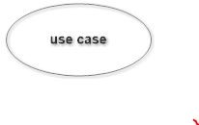

Figure 3.2: Use case

## System

System is used to define the scope of the use case and drawn as a rectangle. This is an optional element but useful when your visualizing large systems. For example you can create all the use cases and then use the system object to define the scope covered by your project. Or you can even use it to show the different areas covered in different releases.

## Package

Package is another optional element that is extremely useful in complex diagrams.

Similar to use class diagrams, packages are used to group together use cases.

## Sequence Diagram

UML sequence diagrams are used to represent or model the flow of messages, events and actions between the objects or components of a system.Time is represented in the vertical direction showing the sequence of interaction of the header elements.Sequence Diagrams are used primarily to design, document and validate the architec ture, interfaces and logic of the system by describing the sequence of actions that need to be performed to complete a task. UML sequence diagrams are useful design tools because they provide a dynamic view of the system behavior which can be difficult to extract from static diagrams or specifications.

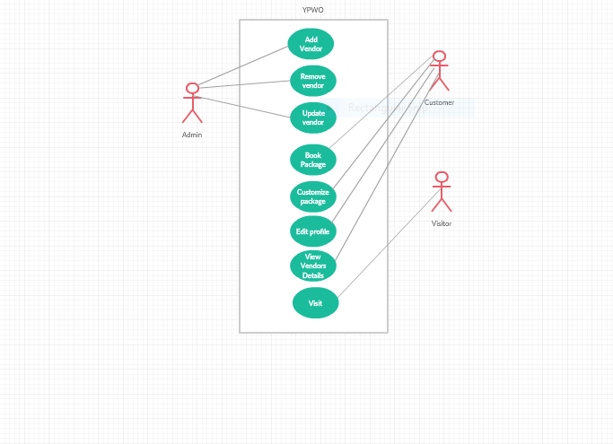

Figure 3.3: YPWO use case Diagram

Although UML sequence diagrams are typically used to describe object-oriented software systems, they are also extremely useful as system engineering tools to design system architectures in business process, as message sequence charts and call flows for telecoms or wireless system design, and for protocol stack design and analysis.

A sequence diagram is an interaction diagram that shows how objects operate with one another and in what order. It is a construct of a message sequence chart. A sequence diagram shows object interactions arranged in time sequence. It depicts the objects and classes involved in the scenario and the sequence of messages exchanged between the objects needed to carry out the functionality of the scenario. Sequence Diagrams are typically associated with use case realizations in the logical View of the system under development. Sequence diagrams are sometimes called event diagrams or event scenarios. A sequence diagram shows, as parallel vertical lines (lifelines), different processes or objects that live simultaneously, and, as horizontal arrows, the messages exchanged between them, in the order in which they occur. This allows the specification of simple runtime scenarios in a graphical manner.

**3.2.3Activity Diagram**

Activity diagram is another important diagram in UML to describe the dynamic aspects of the system.

Activity diagram is basically a flowchart to represent the flow from one activity to another activity. The activity can be described as an operation of the system.

The control flow is drawn from one operation to another. This flow can be sequential, branched, or concurrent. Activity diagrams deal with all type of flow control by using different elements such as fork, join, etc.

The basic purposes of activity diagrams is similar to other four diagrams. It captures the dynamic behavior of the system. Other four diagrams are used to show the message flow from one object to another but activity diagram is used to show message flow from one activity to another.

Activity is a particular operation of the system. Activity diagrams are not only used for visualizing the dynamic nature of a system, but they are also used to construct the executable system by using forward and reverse engineering techniques. The only missing thing in the activity diagram is the message part.

It does not show any message flow from one activity to another. Activity diagram is sometimes considered as the flowchart. Although the diagrams look like a flowchart, they are not. It shows different flows such as parallel, branched, concurrent, and single.

The purpose of an activity diagram can be described as −

* Draw the activity flow of a system.
* Describe the sequence from one activity to another.
* Describe the parallel, branched and concurrent flow of the system.

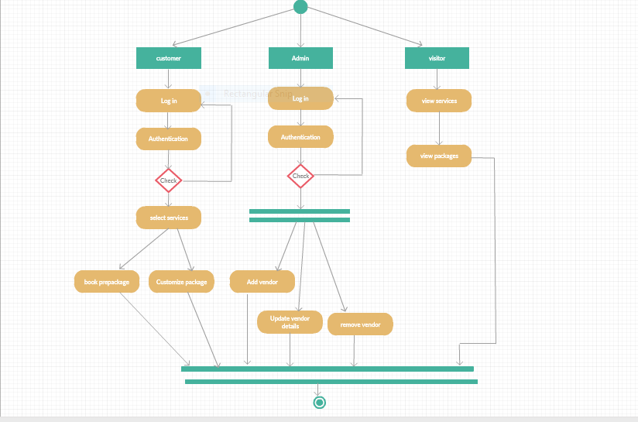

Fig 3.4 Activity Diagram

# SYSTEM DESIGN

Design is the abstraction of a solution; it is a general description of the solution to a problem without the details. Design is view patterns seen in the analysis phase to be a pattern in a design phase. After design phase we can reduce the time required to cre- ate the implementation. The design is a solution, the transition of requirements in two ways of meeting them. The design will determine the success of the system. Based on the proposed system objectives, the major modules are identified and the operations to be carried out are determined. In the design phase of the system the user interaction screen, database tables, inputs, outputs and screen are designed. The database tables are designed by using all the necessary fields in a compact manner. The redundancy and duplication of fields are avoided.

Systems design involves first logical design and the n physical construction of the system. After logical design, a detailed specification of the system, which describes the inputs, outputs, files are developed. During the design phase of system, the following factors are considered.

The important of software design can be stated with a single word quality. Design is placed where quality is fostered in software development. Design is the only way whose requirements are actually translated into a finished software product or system.

* Data Floors: -The movement of data into, around and out of the system
* Data Source: -Temporary and permanent collections of data
* Processors: -Activities to accept, manipulate and deliver data and information
* Procedures: -Methods and routines to achieve the intended results.

## Input Design

The input is the set of values that is provided by the user to the system. The input design must enable the user to provide the error free input to the system for efficient processing. The data is fed into the system using simple interactive xml pages. The pages have been supplied with messages so that user can enter data without facing any difficulty. The data is validated wherever it requires in the project

The main objectives of the input design are as follows:

* + - * Produce effective method of input
      * Achieve high level accuracy
      * Ensure that the input is acceptable and understood by the user The different types of input data handled by the system are:

## External

They are the primary inputs to the system. The external input is what the user supplies to the system. The user can give different types of external inputs in this project such as registration details, login details etc.

## Internal

When the external inputs are obtained from the user, these inputs are transferred to the system as messages. These messages are captured and handled as input for further processing.

In this project the input design is done with Android and PHP codes. The external in- puts are the data given to the system by the user. The necessary external inputs are given to the system by Graphical User Interface(GUI)technology. The GUI system applied to this project enables the user to avoid error and confusion arises while entering the input.

## Output Design

The primary consideration in the design of all output is the information requirement and other objective of the users. It is the most important and direct source of information to the user. A major form of output is a hard copy. Print out should be designed around the output requirements of the user. Each output should be given a specific name or title. The output data is displayed on the visual display unit and output can be redirected to printers and or sorted in a file for later use.

## Database Design

Database is a design to manage large bodies of information. The management of data involves both the definition of structures for the storage information. In addition, the database system must provide for the safety of the information solved, despite system crashes or due to attempts at unauthorized access. For developing an efficient database we have to fulfil certain condition such as controlled redundancy

* + - * Defining the data
      * Inputting the data
      * Locating the data
      * Accessing the data
      * Communicating the data
      * Revising the data

**Objectives Of Database**

In the database design, several objectives are considered such as

* + - * Control of data Integrity
      * Ease of use
      * Control of redundancy
      * Control of security
      * Data independence (Logical and physical)
      * Data storage protection (Record level and Table level)
      * System performance
      * System functions
      * System compatibility

**NORMALIZATION**

Normalization is the term obtained from the Latin word NORMA which means that square used by the carpenter. Normalization is the process of simplifying the relationship between data elements in a record, through normalization a collection of data I a record structure is replaced by successive record structures that are simpler and can be managed efficiently. While designing the database, we have to implement the concept of normalization to avoid data redundancy in the database. Normalization is carried out for four reasons.

* + - * To structure the data so that any pertinent relationship between entities can be represented.
      * To permit simple retrieval of data in response to query and reports required.
      * To simplify data maintenance procedures such as insertion, deletion and updating.
      * To reduce the need to be structure or reorganize data with new application re- quirements arise.

The major normalization strategies are

* + - * First Normal Form
      * Second Normal Form
      * Third Normal Form
      * Boyce/Codd Normal Form(BCNF)

**FIRST NORMAL FORM**

First Normal Form is achieved when all repeating groups in a record are removed, so that record is of fixed length. A repeating group, reoccurrence of a data item or group of data item within a record indicates another relation.

**SECOND NORMAL FORM**

Second Normal Form is achieved when a record is in first normal form and each item in the record is functionally depend on the primary key for identification. In other words, analyst seeks functional dependency. A data item is functionally dependent of its value is uniquely associated with a specific data item is functionally dependent of its value is uniquely associated with a specific item. To achieve second normal form every column in a table that is not dependent on the primary key of the record should be removed and used to form a separate relation.

**THIRD NORMAL FORM**

Third Normal Form is achieved when all transitive dependencies are removed from a record. That is, if A is functionally dependent on B and B is functionally dependent on C, then A is functionally dependent on C.

**BOYCE/CODD NORMAL FORM(BCNF)**

BCNF is often used to distinguish the new 3NF from the old. An attribute possible composite is called as determinant. If other attributes are fully functionally determined this attribute(or on which some other attribute is fully functionally dependent on this attribute).A table is in BCNF , if every determinant is a candidate key. To achieve a table is in BCNF, remove fields which are fully functionally dependent on a determinant, which is not act as a candidate key.

Table 3.1: LOGIN

|  |  |  |  |
| --- | --- | --- | --- |
| **FIELDS** | **DATA TYPE** | **CONSTRAINT** | **DESCRIPTION** |
| email | Varchar2(30) | primary key | It is used to store the unique value |
| Password | Varchar2(20) | Not Null | To store password and should not be null |
| username | Varchar2(20) | Not Null | To store username and should not be null |
| Contact number | Number(10) | Not Null | To store contact number and should not be null |
| address | Varchar2(50) | Not Null | To store the address and should not be null |

Table 3.2: VENDOR

|  |  |  |  |
| --- | --- | --- | --- |
| **FIELDS** | **DATA TYPE** | **CONSTRAINT** | **DESCRIPTION** |
| id | Varchar2(20) | Primary key | It is used to store the unique value |
| Vendor name | Varchar2(20) | Not Null | To store vendor name and should not be null |
| Contact number | Number(10) | Not Null | To store contact number and should not be null |
| rating | Number(1) | Not Null | To store the rating and should not be null |

Table 3.3: PRE PACKAGE

|  |  |  |  |
| --- | --- | --- | --- |
| **FIELDS** | **DATA TYPE** | **CONSTRAINT** | **DESCRIPTION** |
| event | Varchar2(20) | Not Null | Should not be null. |
| package name | Varchar2(20) | Not Null | To store package name and should not be null |
| packageid | Varchar2(5) | Primary key | To store the unique value |
| Vendor name | Varchar2(30) | Not Null | Should not be null. |
| venue | Varchar2(30) | Not Null | Should not be null. |
| Music | Varchar2(20) | Not Null | Should not be null. |
| Cuisine option | Varchar2(30) | Not Null | Should not be null. |
| Theme | Varchar2(30) | Not Null | Should not be null. |
| price | Number(10) | Not Null | Should not be null. |
| vcno | Number(10) | Not Null | Should not be null. |

Table 3.4 Admin

|  |  |  |  |
| --- | --- | --- | --- |
| **FIELDS** | **DATA TYPE** | **CONSTRAINT** | **DESCRIPTION** |
| Emailed | Varchar2(30) | Primary key | To store the unique value |
| password | Varchar2(20) | Not Null | Should not be null |
| Mobile number | Number(10) | Not Null | Should not be null |
| name | Varchar2(50) | Not Null | Should not be null |

Table 3.5 prepackbook

|  |  |  |  |
| --- | --- | --- | --- |
| **FIELDS** | **DATA TYPE** | **CONSTRAINT** | **DESCRIPTION** |
| bookingid | Number(10) | Primary key | To store the unique value |
| custemail | Varchar2(30) | Not Null | Should not be null |
| packid | Varchar2(5) | Not Null | Should not be null |
| dob | date | Not Null | Should not be null |
| totprice | Number(10) | Not Null | Should not be null |

Table 3.6 custbook

|  |  |  |  |
| --- | --- | --- | --- |
| **FIELDS** | **DATA TYPE** | **CONSTRAINT** | **DESCRIPTION** |
| Booking id | Number(10) | Primary key | To store the unique value |
| custemal | Varchar2(30) | Not Null | Should not be null |
| event | Varchar2(100) | foreginkey | Should not be null |
| music | Varchar2(100) | foreginkey | Should not be null |
| cuisine | Varchar2(100) | foreginkey | Should not be null |
| theme | Varchar2(100) | Not null | Should not be null |
| vname | Varchar2(30) | Not null | Should not be null |
| vcno | Number(10) | Not null | Should not be null |
| venue | Varchar2(100) | Not null | Should not be null |
| dob | date | Not null | Should not be null |
| totprice | Number(0) | Not null | Should not be null |

# TOOLS AND PLATFORMS

## Eclipse Luna

## Eclipse is an [integrated development environment](https://en.wikipedia.org/wiki/Integrated_development_environment) (IDE) used in [computer programming](https://en.wikipedia.org/wiki/Computer_programming), and is the most widely used Java IDE. It contains a base [workspace](https://en.wikipedia.org/wiki/Workspace) and an extensible [plug-in](https://en.wikipedia.org/wiki/Plug-in_(computing)) system for customizing the environment. Eclipse is written mostly in [Java](https://en.wikipedia.org/wiki/Java_(programming_language)) and its primary use is for developing Java applications, but it may also be used to develop applications in other  [programming languages](https://en.wikipedia.org/wiki/Programming_language) via plugins,including [Ada](https://en.wikipedia.org/wiki/Ada_(programming_language)), [ABAP](https://en.wikipedia.org/wiki/ABAP), [C](https://en.wikipedia.org/wiki/C_(programming_language)), [C++](https://en.wikipedia.org/wiki/C%2B%2B), [C#](https://en.wikipedia.org/wiki/C_Sharp_(programming_language)), [Clojure](https://en.wikipedia.org/wiki/Clojure), [COBOL](https://en.wikipedia.org/wiki/COBOL), [D](https://en.wikipedia.org/wiki/D_(programming_language)), [Erlang](https://en.wikipedia.org/wiki/Erlang_(programming_language)), [Fortran](https://en.wikipedia.org/wiki/Fortran), [Groovy](https://en.wikipedia.org/wiki/Groovy_(programming_language)), [Haskell](https://en.wikipedia.org/wiki/Haskell_(programming_language)), [JavaScript](https://en.wikipedia.org/wiki/JavaScript), [Julia](https://en.wikipedia.org/wiki/Julia_(programming_language)),[[7]](https://en.wikipedia.org/wiki/Eclipse_(software)#cite_note-7) [Lasso](https://en.wikipedia.org/wiki/Lasso_(programming_language)), [Lua](https://en.wikipedia.org/wiki/Lua_(programming_language)), [NATURAL](https://en.wikipedia.org/wiki/Software_AG), [Perl](https://en.wikipedia.org/wiki/Perl), [PHP](https://en.wikipedia.org/wiki/PHP), [Prolog](https://en.wikipedia.org/wiki/Prolog), [Python](https://en.wikipedia.org/wiki/Python_(programming_language)), [R](https://en.wikipedia.org/wiki/R_(programming_language)), [Ruby](https://en.wikipedia.org/wiki/Ruby_(programming_language)) (including [Ruby on Rails](https://en.wikipedia.org/wiki/Ruby_on_Rails) framework), [Rust](https://en.wikipedia.org/wiki/Rust_(programming_language)), [Scala](https://en.wikipedia.org/wiki/Scala_(programming_language)), and [Scheme](https://en.wikipedia.org/wiki/Scheme_(programming_language)). It can also be used to develop documents with [LaTeX](https://en.wikipedia.org/wiki/LaTeX) (via a TeXlipse plug-in) and packages for the software [Mathematica](https://en.wikipedia.org/wiki/Mathematica). Development environments include the Eclipse Java development tools (JDT) for Java and Scala, Eclipse CDT for C/C++, and Eclipse PDT for PHP, among others.

## The Java Development Tools (JDT) project provides a plug-in that allows Eclipse to be used as a Java IDE, PyDev is a plugin that allows Eclipse to be used as a Python IDE, C/C++ Development Tools (CDT) is a plug-in that allows Eclipse to be used for developing application using C/C++, the Eclipse Scala plug-in allows Eclipse to be used an IDE to develop Scala applications and PHPeclipse is a plug-in to eclipse that provides complete development tool for PHP.

## An eclipse perspective is the name given to an initial collection and arrangement of views and an editor area. The default perspective is called java. An eclipse window can have multiple perspectives open in it but only one perspective is active at any point of time. A user can switch between open perspectives or open a new perspective. The active perspective controls what appears in some menus and tool bars.

## Java

Java is a popular programming language, created in 1995.

It is owned by Oracle, and more than **3 billion** devices run Java.

It is used for:

* Mobile applications (specially Android apps)
* Desktop applications
* Web applications
* Web servers and application servers
* Games
* Database connection
* And much, much more!

Java is a [general-purpose](https://en.wikipedia.org/wiki/General-purpose_language) [programming language](https://en.wikipedia.org/wiki/Programming_language) that is [class-based](https://en.wikipedia.org/wiki/Class-based_programming), [object-oriented](https://en.wikipedia.org/wiki/Object-oriented_programming), and designed to have as few implementation [dependencies](https://en.wikipedia.org/wiki/Dependency_(computer_science)) as possible. It is intended to let [application developers](https://en.wikipedia.org/wiki/Application_developer) "[write once, run anywhere](https://en.wikipedia.org/wiki/Write_once,_run_anywhere)" (WORA), meaning that compiled Java code can run on all platforms that support Java without the need for recompilation. Java applications are typically compiled to ["bytecode"](https://en.wikipedia.org/wiki/Java_bytecode) that can run on any [Java virtual machine](https://en.wikipedia.org/wiki/Java_virtual_machine) (JVM) regardless of the underlying [computer architecture](https://en.wikipedia.org/wiki/Computer_architecture). The [syntax](https://en.wikipedia.org/wiki/Syntax_(programming_languages)) of Java is similar to [C](https://en.wikipedia.org/wiki/C_(programming_language)) and [C++](https://en.wikipedia.org/wiki/C%2B%2B), but it has fewer [low-level](https://en.wikipedia.org/wiki/Low-level_programming_language) facilities than either of them. As of 2018, Java was one of the most [popular programming languages in use](https://en.wikipedia.org/wiki/Measuring_programming_language_popularity) according to [GitHub](https://en.wikipedia.org/wiki/GitHub), particularly for [client-server](https://en.wikipedia.org/wiki/Client%E2%80%93server) [web applications](https://en.wikipedia.org/wiki/Web_applications), with a reported 9 million developers.

Java was originally developed by [James Gosling](https://en.wikipedia.org/wiki/James_Gosling) at [Sun Microsystems](https://en.wikipedia.org/wiki/Sun_Microsystems) ([which has since been acquired by Oracle](https://en.wikipedia.org/wiki/Sun_acquisition_by_Oracle)) and released in 1995 as a core component of Sun Microsystems' [Java platform](https://en.wikipedia.org/wiki/Java_(software_platform)). The original and [reference implementation](https://en.wikipedia.org/wiki/Reference_implementation) Java [compilers](https://en.wikipedia.org/wiki/Compiler), virtual machines, and [class libraries](https://en.wikipedia.org/wiki/Library_(computing)) were originally released by Sun under [proprietary licenses](https://en.wikipedia.org/wiki/Proprietary_license). As of May 2007, in compliance with the specifications of the [Java Community Process](https://en.wikipedia.org/wiki/Java_Community_Process), Sun had [relicensed](https://en.wikipedia.org/wiki/Software_relicensing) most of its Java technologies under the [GNU General Public License](https://en.wikipedia.org/wiki/GNU_General_Public_License). Meanwhile, others have developed alternative implementations of these Sun technologies, such as the [GNU Compiler for Java](https://en.wikipedia.org/wiki/GNU_Compiler_for_Java) (bytecode compiler), [GNU Class path](https://en.wikipedia.org/wiki/GNU_Classpath) (standard libraries), and Iced Tea-Web (browser plugin for applets).

There were five primary goals in the creation of the Java language:[[17]](https://en.wikipedia.org/wiki/Java_(programming_language)#cite_note-design_goals-17)

1. It must be "simple, object-oriented, and familiar".
2. It must be "robust and secure".
3. It must be "architecture-neutral and portable".
4. It must execute with "high performance".
5. It must be "interpreted, threaded, and dynamic".

Java uses an [automatic garbage collector](https://en.wikipedia.org/wiki/Garbage_collection_(computer_science)) to manage memory in the [object lifecycle](https://en.wikipedia.org/wiki/Object_lifetime). The programmer determines when objects are created, and the Java runtime is responsible for recovering the memory once objects are no longer in use. Once no references to an object remain, the [unreachable memory](https://en.wikipedia.org/wiki/Unreachable_memory) becomes eligible to be freed automatically by the garbage collector. Something similar to a [memory leak](https://en.wikipedia.org/wiki/Memory_leak) may still occur if a programmer's code holds a reference to an object that is no longer needed, typically when objects that are no longer needed are stored in containers that are still in use. If methods for a non-existent object are called, a "null pointer exception" is thrown.

A **class** that is not declared **public** may be stored in any .java file. The compiler will generate a class file for each class defined in the source file. The name of the class file is the name of the class, with *.class* appended. For class file generation, [anonymous classes](https://en.wikipedia.org/wiki/Class_(computer_programming)#Unnamed) are treated as if their name were the concatenation of the name of their enclosing class, a *$*, and an integer.

The [keyword](https://en.wikipedia.org/wiki/List_of_Java_keywords) **public** denotes that a method can be called from code in other classes, or that a class may be used by classes outside the class hierarchy. The class hierarchy is related to the name of the directory in which the .java file is located. This is called an access level modifier. Other access level modifiers include the keywords **private** and **protected**.

The keyword **static** in front of a method indicates a [static method](https://en.wikipedia.org/wiki/Method_(computer_programming)#Static_methods), which is associated only with the class and not with any specific instance of that class. Only static methods can be invoked without a reference to an object. Static methods cannot access any class members that are not also static. Methods that are not designated static are instance methods and require a specific instance of a class to operate.

The keyword **void** indicates that the main method does not return any value to the caller. If a Java program is to exit with an error code, it must call System.exit() explicitly.

The method name "main" is not a keyword in the Java language. It is simply the name of the method the Java launcher calls to pass control to the program. Java classes that run in managed environments such as applets and [Enterprise JavaBeans](https://en.wikipedia.org/wiki/Enterprise_JavaBeans) do not use or need a main() method.

The primary objective of [Java programming](https://www.javatpoint.com/java-tutorial) language creation was to make it portable, simple and secure programming language. Apart from this, there are also some excellent features which play an important role in the popularity of this language. The features of Java are also known as java buzzwords.

A list of most important features of Java language is given below.

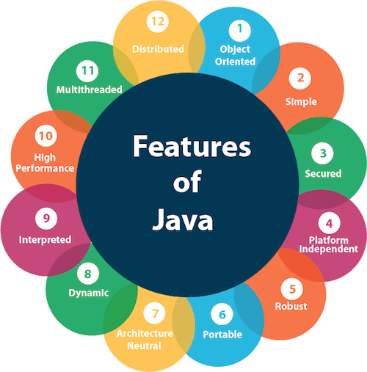

1. Simple
2. Object-Oriented
3. Portable
4. Platform independent
5. Secured
6. Robust
7. Architecture neutral
8. Interpreted
9. High Performance
10. Multithreaded
11. Distributed
12. Dynamic

**Simple:** Java is very easy to learn, and its syntax is simple, clean and easy to understand. According to Sun, Java language is a simple programming language because:

* Java syntax is based on C++ (so easier for programmers to learn it after C++).
* Java has removed many complicated and rarely-used features, for example, explicit pointers, operator overloading, etc.
* There is no need to remove unreferenced objects because there is an Automatic Garbage Collection in Java.

### **Object-oriented**

Java is an [object-oriented](https://www.javatpoint.com/java-oops-concepts) programming language. Everything in Java is an object. Object-oriented means we organize our software as a combination of different types of objects that incorporates both data and behavior.

Object-oriented programming (OOPs) is a methodology that simplifies software development and maintenance by providing some rules.

### **Platform Independent**

Java is platform independent because it is different from other languages like [C](https://www.javatpoint.com/c-programming-language-tutorial), [C++](https://www.javatpoint.com/cpp-tutorial), etc. which are compiled into platform specific machines while Java is a write once, run anywhere language. A platform is the hardware or software environment in which a program runs.

The Java platform differs from most other platforms in the sense that it is a software-based platform that runs on the top of other hardware-based platforms. It has two components:

1. Runtime Environment
2. API(Application Programming Interface)

### **Secured**

Java is best known for its security. With Java, we can develop virus-free systems. Java is secured because:

* **No explicit pointer**
* **Java Programs run inside a virtual machine sandbox**

### **Robust**

Robust simply means strong. Java is robust because:

* It uses strong memory management.
* There is a lack of pointers that avoids security problems.
* There is automatic garbage collection in java which runs on the Java Virtual Machine to get rid of objects which are not being used by a Java application anymore.
* There are exception handling and the type checking mechanism in Java. All these points make Java robust.

### **Architecture-neutral**

Java is architecture neutral because there are no implementation dependent features, for example, the size of primitive types is fixed.

In C programming, int data type occupies 2 bytes of memory for 32-bit architecture and 4 bytes of memory for 64-bit architecture. However, it occupies 4 bytes of memory for both 32 and 64-bit architectures in Java.

### **Portable**

Java is portable because it facilitates you to carry the Java bytecode to any platform. It doesn't require any implementation.

### **High-performance**

Java is faster than other traditional interpreted programming languages because Java bytecode is "close" to native code. It is still a little bit slower than a compiled language (e.g., C++). Java is an interpreted language that is why it is slower than compiled languages, e.g., C, C++, etc.

### **Distributed**

Java is distributed because it facilitates users to create distributed applications in Java. RMI and EJB are used for creating distributed applications. This feature of Java makes us able to access files by calling the methods from any machine on the internet.

### **Multi-threaded**

A thread is like a separate program, executing concurrently. We can write Java programs that deal with many tasks at once by defining multiple threads. The main advantage of multi-threading is that it doesn't occupy memory for each thread. It shares a common memory area. Threads are important for multi-media, Web applications, etc.

### **Dynamic**

Java is a dynamic language. It supports dynamic loading of classes. It means classes are loaded on demand. It also supports functions from its native languages, i.e., C and C++.Java supports dynamic compilation and automatic memory management (garbage collection).

**3.4.3 Angular**

UI designing is one of the most crucial parts of any application. UI is where the user interacts with any application, hence it has to be designed in a user-friendly manner. Many frameworks have come into existence for the same. Angular is one such very powerful framework for building client applications using any scripting language such as JS or TypeScript. The most preferred scripting language for Angular is TypeScript which can again be compiled to JavaScript. Any UI designer would appreciate Angular if he already knows any traditional approaches as this framework helps us in designing application with better performance and maintainability for both mobiles and desktops.

AngularJS is based on the model view controller, whereas Angular 2 is based on the components structure. Angular 4 works on the same structure as Angular2 but is faster when compared to Angular2.

Angular4 uses TypeScript 2.2 version whereas Angular 2 uses TypeScript version 1.8. This brings a lot of difference in the performance.

To install Angular 4, the Angular team came up with Angular CLI which eases the installation.

The Angular 4 app folder has the following **folder structure** −

* **e2e** − end to end test folder. Mainly e2e is used for integration testing and helps ensure the application works fine.
* **node_modules** − The npm package installed is node_modules. You can open the folder and see the packages available.
* **src** − This folder is where we will work on the project using Angular 4.

The Angular 4 app folder has the following **file structure** −

* **.angular-cli.json** − It basically holds the project name, version of cli, etc.
* **.editorconfig** − This is the config file for the editor.
* **.gitignore** − A .gitignore file should be committed into the repository, in order to share the ignore rules with any other users that clone the repository.
* **karma.conf.js** − This is used for unit testing via the protractor. All the information required for the project is provided in karma.conf.js file.
* **package.json** − The package.json file tells which libraries will be installed into node_modules when you run npm install.

The src folder is the main folder, which internally has a different file structure.

**app**-It contains the files described below. These files are installed by angular-cli by default.

* app.module.ts − If you open the file, you will see that the code has reference to different libraries, which are imported. Angular-cli has used these default libraries for the import – angular/core, platform-browser. The names itself explain the usage of the libraries.

They are imported and saved into variables such as **declarations, imports, providers**, and **bootstrap**.

**declarations** − In declarations, the reference to the components is stored. The Appcomponent is the default component that is created whenever a new project is initiated. We will learn about creating new components in a different section.

**imports** − This will have the modules imported as shown above. At present, BrowserModule is part of the imports which is imported from @angular/platform-browser.

**providers** − This will have reference to the services created. The service will be discussed in a subsequent chapter.

**bootstrap** − This has reference to the default component created, i.e., AppComponent.

* **app.component.css** − You can write your css structure over here. Right now, we have added the background color to the div as shown below.
* **app.component.html** − The html code will be available in this file.

This is the default html code currently available with the project creation.

* **app.component.spec.ts** − These are automatically generated files which contain unit tests for source component.
* **app.component.ts** − The class for the component is defined over here. You can do the processing of the html structure in the .ts file. The processing will include activities such as connecting to the database, interacting with other components, routing, services, etc.

**Angular and TypeScript**

Angular is one of the most powerful client-side U.I. framework which can be used to develop **complex**, **customizable**, **modern**, **responsive** and **userfriendly** web applications. Some such applications are PayPal, Netflix, Weather etc.Angular is a single framework which addresses concernsof bothmobileanddesktop application.The Angular framework has chosen a **new statically-typed**, **client-side scripting** language called TypeScript, which beautifully works around most if not all such pitfalls of JavaScript. The Angular team recommends the usage of TypeScript for Angular applications. Hence, to start building Angular applications, we would need to learn to write simple TypeScriptcode first and then look at the Angular application design.

**Pitfalls of JavaScript**

JavaScript is the language used for client side scripting. We can do client side validations, DOM manipulation, Ajax calls etc using JavaScript. We can also use JavaScript frameworks for writing complex business logic which runs on the client side.

As the complexity of the JavaScript code increases, it gradually becomes difficult in coding and maintaining. This is because of the following pitfalls of JavaScript language.

**Dynamic Typing**: Dynamic typing means deciding the data type of the variable dynamically at runtime which results in recompilation every time the code is executed.

**Interpreted Language**: Interpreted Language is a language in which the code instructions are executed directly without prior compilation to machine-language instructions hence we will not get to know the errors until the code is executed.

**Minimal Object Oriented support**: JS supports minimal Object Oriented concepts like classes, encapsulation, inheritance which helps in readability and reusability of the code.

**Minimal IDE support**: Integrated development environment (IDE) is a software application that provides all necessary options like code refactoring, intellisense support, Debugging support to software programmers for software development which is least supported in JS.

Albeit all these shortcomings, we are still dependent on JS as it is the most common scripting language for browsers. But as programmers, we might be in luck.

The solution can be to choose a language which is rich in features and the code can be converted to JavaScript for browsers. This process of converting code written in one language into another language is generally called Transpilation.

TypeScript is one such language whose code can be transpiled to JavaScript. This conversion is required because browser cannot understand TypeScript code.

**What is TypeScript**

TypeScript is a typed superset of JavaScript that transpiles to JavaScript.

* TypeScript makes the development of JavaScript nearer to a more traditional object oriented experience.
* TypeScript is based on [ECMAScript](http://www.ecma-international.org/) 7 proposals.
* Apart from the EcmaScript specification, TypeScript has its own features as well.
* Any valid JavaScript is TypeScript.

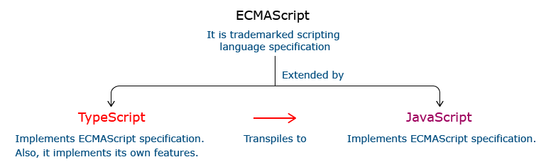

**Relationship Between TypeScript and JavaScript**

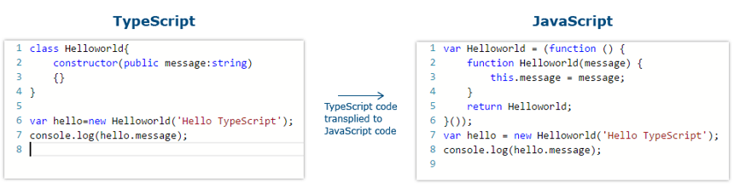

**I**n the code given above, the TypeScript class HelloWorld is converted to a self invoking function in JavaScript when transpiled.

**Features Of TypeScript**

**Static Typing**: It adds static typing to JavaScript, due to which the readability of the code improves and also helps in finding more early compilation errors than the runtime errors.

**Modules support:**TypeScript provides an option to create modules so that we can modularize the code for easy maintenance. Modules also help in making the application scalable.

**Object Oriented Programming:**TypeScript supports object oriented programming features such as classes, encapsulation, interface, inheritance and so on which help in creating highly structured and reusable code.

**Open Source:**TypeScript is open source. The source code of TypeScript can be downloaded from github.

**Cross Platform: It works across platforms.**

**Tooling Support:**TypeScript works extremely well with Sublime Text, Eclipse, and almost all major IDEs as compared to JavaScript

**3.4. 2 Visual Studio Code Ide**

Visual Studio Code is a source-code editor developed by Microsoft for Windows, Linux and macOS. It includes support for debugging, embedded Git control and GitHub, syntax highlighting, intelligent code completion, snippets, and code refactoring. It is highly customizable, allowing users to change the theme, keyboard shortcuts, preferences, and install extensions that add additional functionality. The source code is free and open source and released under the permissive MIT License. The compiled binaries are freeware and free for private or commercial use.

Visual Studio Code is based on Electron, a framework which is used to deploy Node.js applications for the desktop running on the Blink layout engine. Although it uses the Electron framework, the software does not use Atom and instead employs the same editor component (codenamed "Monaco") used in Azure DevOps (formerly called Visual Studio Online and Visual Studio Team Services).

Typescript code can be written using several IDEs such as - Eclipse IDE, NetBeans IDE, Visual Studio Code IDE etc. We are prefer using Visual Studio Code IDE as it is a lightweight cross-platform editor which comes with built-in TypeScript support.

Typescript code is written in Visual Studio Code IDE in the following way:

**Step 1:**Create a folder on your desktop. This folder will be used as a work-space for Visual Studio Code. Let us name it **TypeScript_WorkSpace.**

**Step 2:** Create a folder and name it as **Demo**, inside the previously created folder. This folder will be used as a project folder.

**Step 3:**Launch Visual Studio Code IDE. Once launched, close the welcome page. We should get a screen similar to the one shown below.

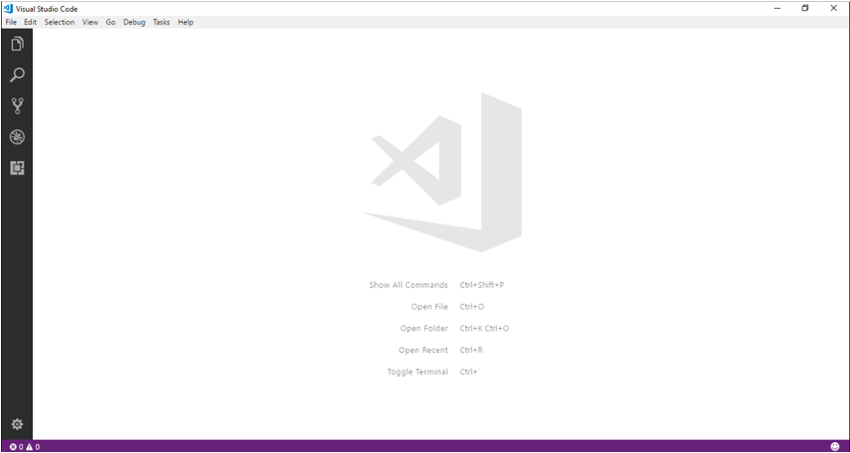

**Step 4:**Next step is to select a workspace. From the **File** menu, select **OpenFolder,** browse for the TypeScript_Demos folder and select it.

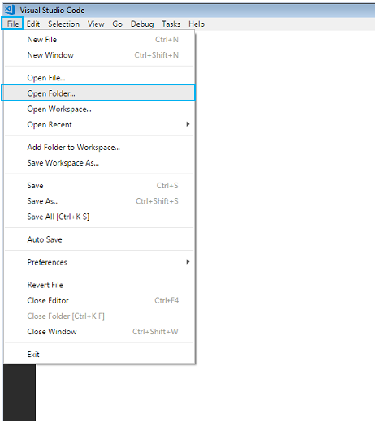

**Step 5:**The IDE will restart and the folder will be selected as work-space. We will also have the **TS_Demo** project folder as shown below.

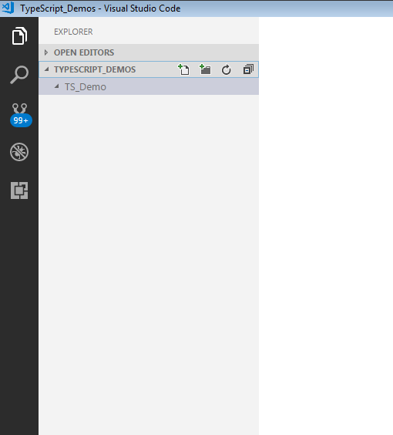

**Step 6:** Let us create a typescript file. Create a file named **firstApp.ts** in the project folder.

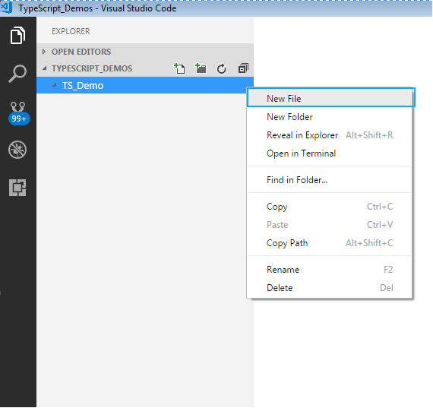

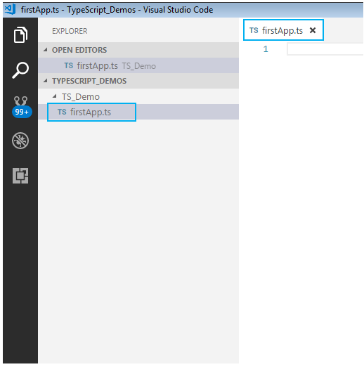

To start with the first application in TypeScript, in already created firstApp.ts file, give a console.log

statement and save it.

Here is how to do this:

**Step 7:** We shall print a welcome message when we run the above file. To do so, let us code as shown

**console.log("Hello! Welcome to TypeScript");**

**Step 8:**

To execute the code, we will have to navigate to the project folder. For this, we will use windows command prompt through VSCode. Open the command prompt by following step:

* Navigate to View tab in VSCode.
* Select Integrated Terminal.

Alternatively, you can use the shortcut, **ctrl+`**, to open the command prompt. We will get the command prompt as shown below.

From the command prompt navigate to the folder in which the ts file resides and **transpile**the **.ts** file using the **tsc**command as follows:

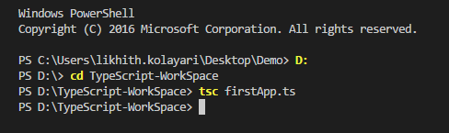

**Step 9:** Run the transpiled **.js** file using  **node**  command . On execution of the code, the output is

displayed on the console as shown.

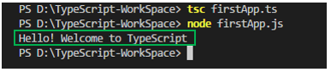

**3.4.5 Oracle**

The Oracle Server is a relational database management system that provides an open, comprehensive, and integrated approach to information management. An Oracle Server consists of an Oracle database and an Oracle instance. The following sections describe the relationship between the database and the instance.

### Structured Query Language (SQL)

SQL (pronounced SEQUEL) is the programming language that defines and manipulates the database. SQL databases are relational databases; this means simply that data is stored in a set of simple relations. A database can have one or more tables. And each table has columns and rows. A table that has an employee database, for example, might have a column called employee number and each row in that column would be an employee's employee number.

You can define and manipulate data in a table with SQL commands. You use data definition language (DDL) commands to set up the data. DDL commands include commands to creating and altering databases and tables.

You can update, delete, or retrieve data in a table with data manipulation commands (DML). DML commands include commands to alter and fetch dat. The most common SQL command is the SELECT command, which allows you to retrieve data from the database.

In addition to SQL commands, the Oracle Server has a procedural language called PL/SQL. PL/SQL enables the programmer to program SQL statements. It allows you to control the flow of a SQL program, to use variables, and to write error-handling procedures.

### **Database Structure**

An Oracle database has both a physical and a logical structure. Because the physical and logical server structure are separate, the physical storage of data can be managed without affecting the access to logical storage structures.

**Physical Database Structure**An Oracle database's physical structure is determined by the operating system files that constitute the database. Each Oracle database is made of three types of files: one or more datafiles, two or more redo log files, and one or more control files. The files of an Oracle database provide the actual physical storage for database information.

**Logical Database Structure** An Oracle database's logical structure is determined by

* one or more tablespaces. (A tablespace is a logical area of storage explained later in this chapter.)
* the database's schema objects. A *schema* is a collection of objects. *Schema objects* are the logical structures that directly refer to the database's data. Schema objects include such structures as tables, views, sequences, stored procedures, synonyms, indexes, clusters, and database links.

The logical storage structures, including tablespaces, segments, and extents, dictate how the physical space of a database is used. The schema objects and the relationships among them form the relational design of a database.

### **An Oracle Instance**

Every time a database is started, a system global area (SGA) is allocated and Oracle background processes are started. The system global area is a an area of memory used for database information shared by the database users. The combination of the background processes and memory buffers is called an Oracle *instance.*

An Oracle instance has two types of processes: user processes and Oracle processes.

A user process executes the code of an application program (such as an Oracle Forms application) or an Oracle Tool (such as Server Manager).Oracle processes are server processes that perform work for user processes and background processes that perform maintenance work for the Oracle Server.

# CHAPTER 4 SYSTEM TESTING

Software testing is an integral part of to ensure software quality, some software organi- zations are reluctant to include testing in their software cycle, because they are afraid of the high cost associated with the software testing .There are several factors that at- tribute the cost of software testing. Creating and maintaining large number of test cases is a time consuming process. Furthermore, it requires skilled and experienced testers to develop great quality test cases.

Even with the wide availability of automation tools for testing, the degree of automa- tion mostly remains at the automated test script level and generally significant amount of human intervention is required in testing. In addition data collected, as testing is conducted provides a good indication of software quality as a while. The debugging process is the most unpredictable part of testing process. Testing begins at the module level and work towards the integration of entire computer based system. No testing is completed without verification and validation part.

The goal of verification and validation activities are to access and improve the qual- ity of work products generated during the development and modification of the soft- ware. Testing plays a vital role in determining the reliability and efficiency of the software and hence is very important stage in software development. Tests are to be conducted on the software to evaluate its performance under a number of conditions. Ideally, it should do so at the level of each module and also when all of them are inte- grated to form the completed system.

In the project ”E-Medication Reminder App And Healthcare system” the testing has been successfully handled with the modules. The test data was given to each and every module in all respect and got the desired output. Each module that has been tested is found working properly.

# UNIT TESTING

Here we test each module individually and integrated the overall system. Unit testing focuses verification efforts even in the smallest unit of software design in each module. This is known as ”module testing”. The modules of this project are tested separately. This testing is carried out in the programming style itself. In this testing each module is focused to work satisfactorily as regard to expected output from the module. There are some validation checks for the fields. Unit testing gives stress on the modules of the project independently of one another, to find errors. Different modules are tested against the specifications produced during the design of the modules. Unit testing is done to test the working of individual modules with test servers. Program unit is usu- ally small enough that the programmer who developed it can test it in a great detail. Unit testing focuses first on that the modules to locate errors. These error are verified and corrected and so that the unit perfectly fits to the project.

# INTEGRATION TESTING

Data can be lost across an interface, one module can have an adverse effect on the other sub-functions, when combined they may not perform the desired functions. Integrated testing is the systematic testing to uncover the errors within the interface. This testing is done with simple data and the developed system has run successfully with this simple data. The need for integrated system is to find the overall system performance. The Modules of this project are connected and tested. After splitting the programs into units, the units were tested together to see the defects between each module and function. It is testing to one or more modules or functions together with the intent of finding interface defects between the modules or functions. Testing completed at as part of unit or functional testing, integration testing can involve putting together of groups of modules and functions with the goal of completing and verifying meets the system requirements.

# SYSTEM TESTING

System testing focuses on testing the system as a whole. System Testing is a crucial step in Quality Management Process. In the Software Development Life Cycle, System Test-

ing is the first level where the System is tested as a whole. The System is tested to verify whether it meets the functional and technical requirements. The application/System is tested in an environment that closely resembles the production environment where the application will be finally deployed. The perquisites for System Testing are:-

* + - All the components should have been successfully Unit Tested.
    - All the components should have been successfully integrated.

Testing should be completed in an environment closely resembling the production en- vironment. When necessary iterations of System Testing are done in multiple environ- ments.

# USER ACCEPTANCE TESTING

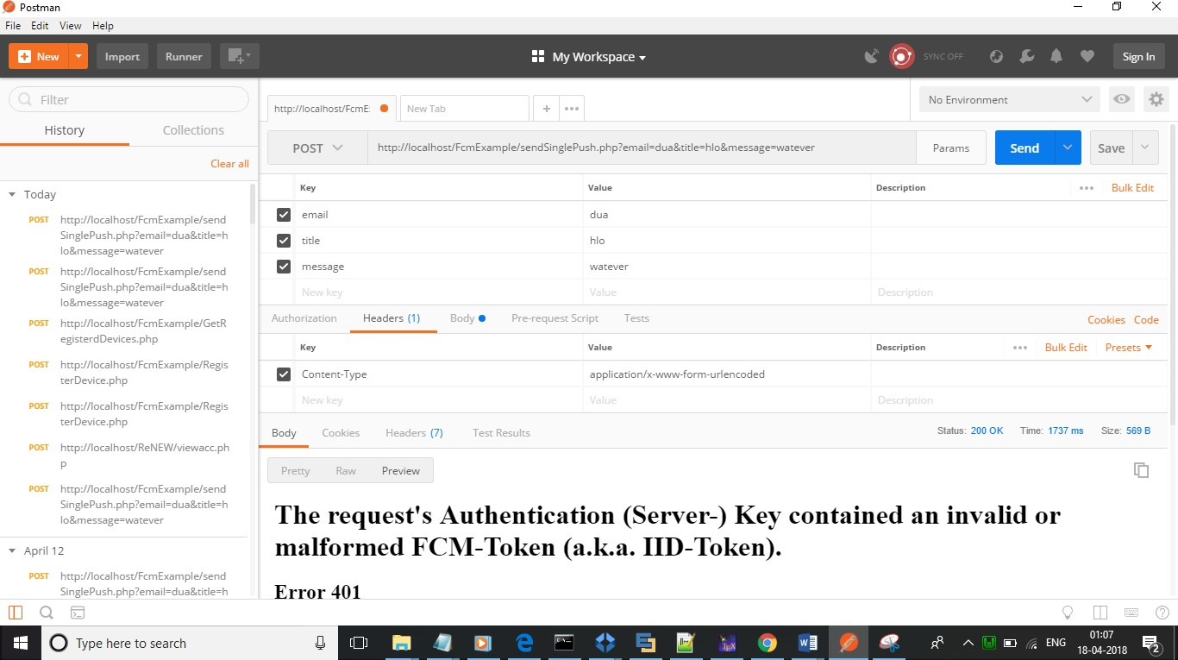The system was tested by a small client community to see if the program met the re- quirements defined the analysis stage. It was fond to be satisfactory. In this phase, the system is fully tested by the client community against the requirements defined in the analysis and design stages, corrections are made as required, and the production system is built. User acceptance of the system is key factor for success of the system.

Figure 4.1: Test case using POSTMAN

# CHAPTER 5 SYSTEM IMPLEMENTATION

The implementation is one phase of software development. Implementation is that stage in the project where theoretical design is turned into working system. Implementation involves placing the complete and tested software system into actual work environ- ment. Implementation is concerned with translating design specification with source code. The primary goal of implementation is to write the source code to its specifi- cation that can be achieved by making the source code clear and straight forward as possible. Implementation means the process of converting a new or revised system de- sign into operational one. The three types of implementation are:-implementation of a computerized system to replace a manual system, implementation of a new system to replace existing one and implementation of a modified system to replace an existing one.

The implementation is the final stage and it is an important phase. It involves the individual programming ; system testing, user training , and the operational running of developed proposed system that constitute the application subsystem. The implemen- tation phase of the software development is concerned with translating design speci- fication in the source code. The user tests the developed system and the changes are according to the needs. Before implementation, Several tests have been conducted to ensure no errors encountered during the operation. The implementation phase ends with an evaluation of the system after placing it into operation of time. The validity and proper functionality of all the modules of the developed application is assured during the process of implementation. Implementation is the process of assuring that the infor- mation system is operational and then allowing user to take over its operation for use and evaluation. Implementation is the stage in the project where the theoretical design is turned into a working system. The implementation phase constructs ,installs and op- erated the new system. The most crucial stage in achieving a new successful system is that it works effectively and efficiently.

# CHAPTER 6 CONCLUSION

YouParty_WeOrganize is an application which gives you flexibility of selecting (all or few) services of your choice, along with that the user can choose the vendor too. The application acts as a pool of all available services and the vendors who can provide the same. YouParty_WeOrganize, which helps the people by opt for a packages that would cover everything or giving flexibility of selecting a or few services of what they need. Only the registered user can book a service. User has to provide their full name, address etc. while registering Estimation slip can be downloaded by the logged in user. Non users can only view all the services and vendors available. An admin part can be there for managing the services and vendors. The project is done by using Angular 4 as front end and oracle as Back end.

User can create a package with save it for later option. For any created package user can select a vendor at any time. Vendor selection should be possible only after providing the date of the event. Only those vendors who can take up the order should be shown to the user. Vendors have their own limits of accepting the order quantity/limit

# CHAPTER 7 REFERENCES

* + - Bipin .C.Desai,An Introduction To Database System published by West.Publishing Company in 1990.
    - Somer Vilie, Software Engineering published by Pearson in March13,2010.
    - Sudarshan Silberschatz, Database System Concepts published by MCGraw- Hill Publication 2013.
    - Henry F.Korth and Abraham Silberschatz,Database System Concepts published by MCGraw-Hill in 1986.

# CHAPTER 8 APPENDENIX

* 1. **SCREEN SHOTS INPUT FORM, OUTPUT FORMS**

About us

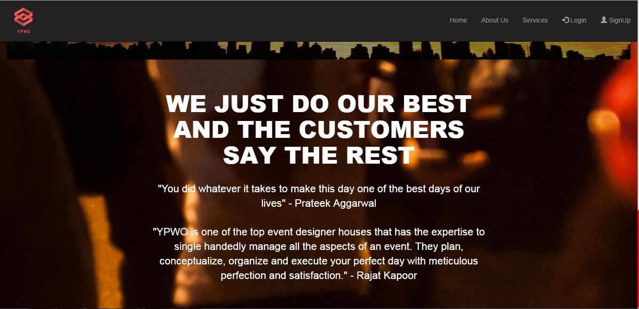

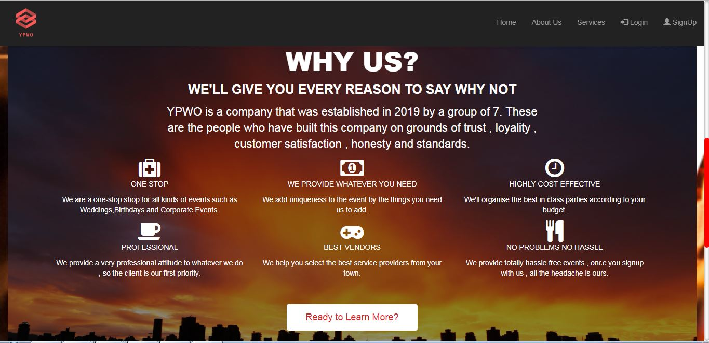

Register/sign up

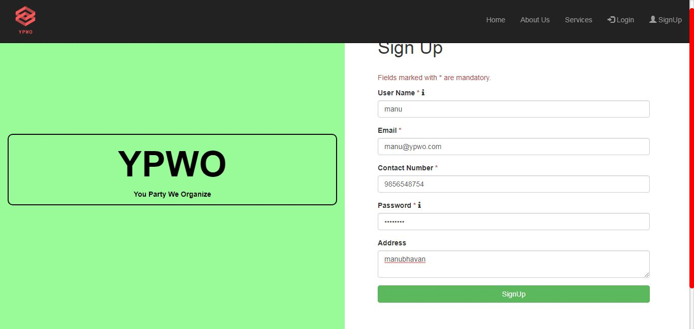

Sign up successful

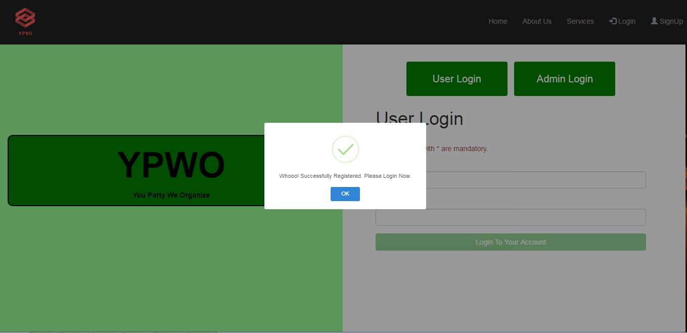

Admin login

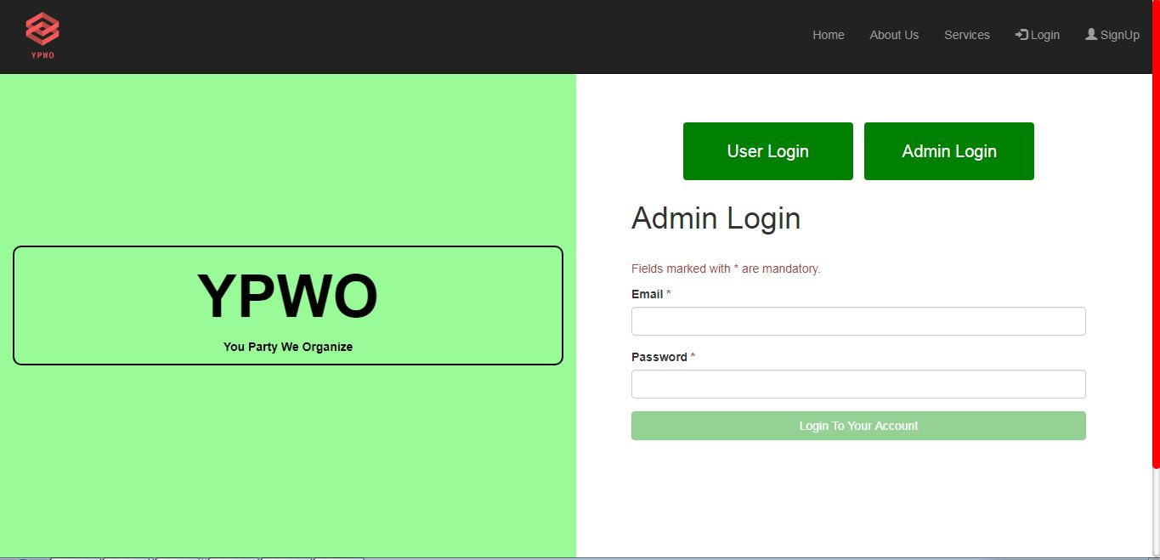

Admin home

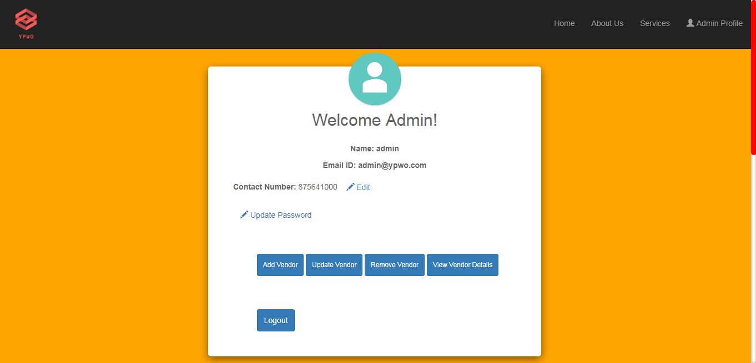

Add Vendor

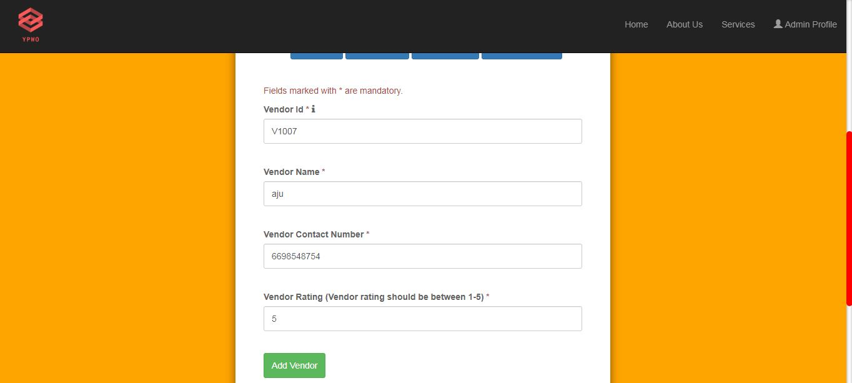

Update Vendor Name

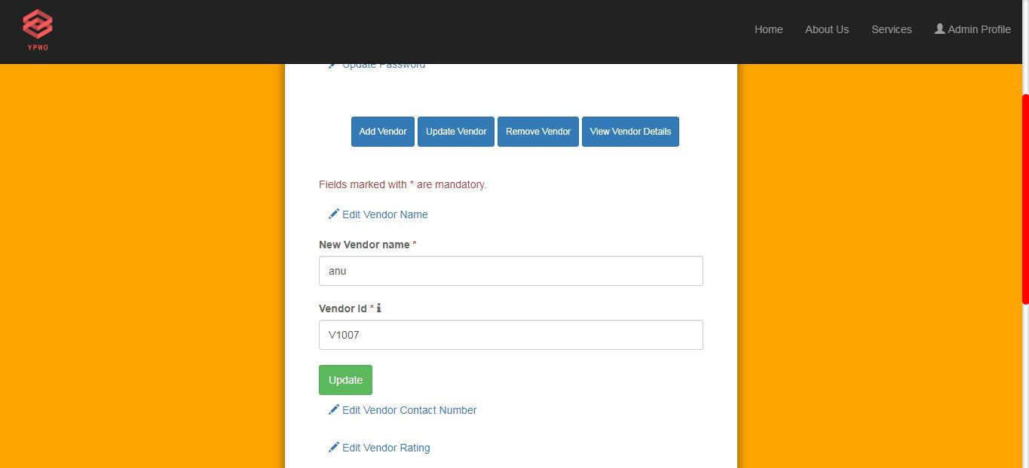

Update vendor Contact

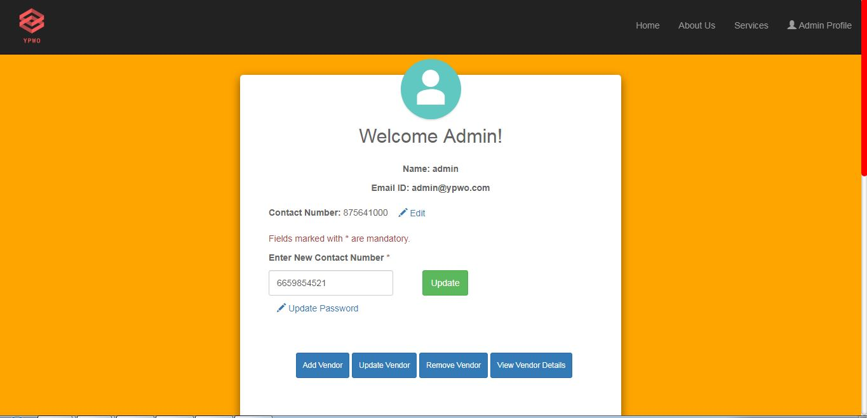

Remove vendor

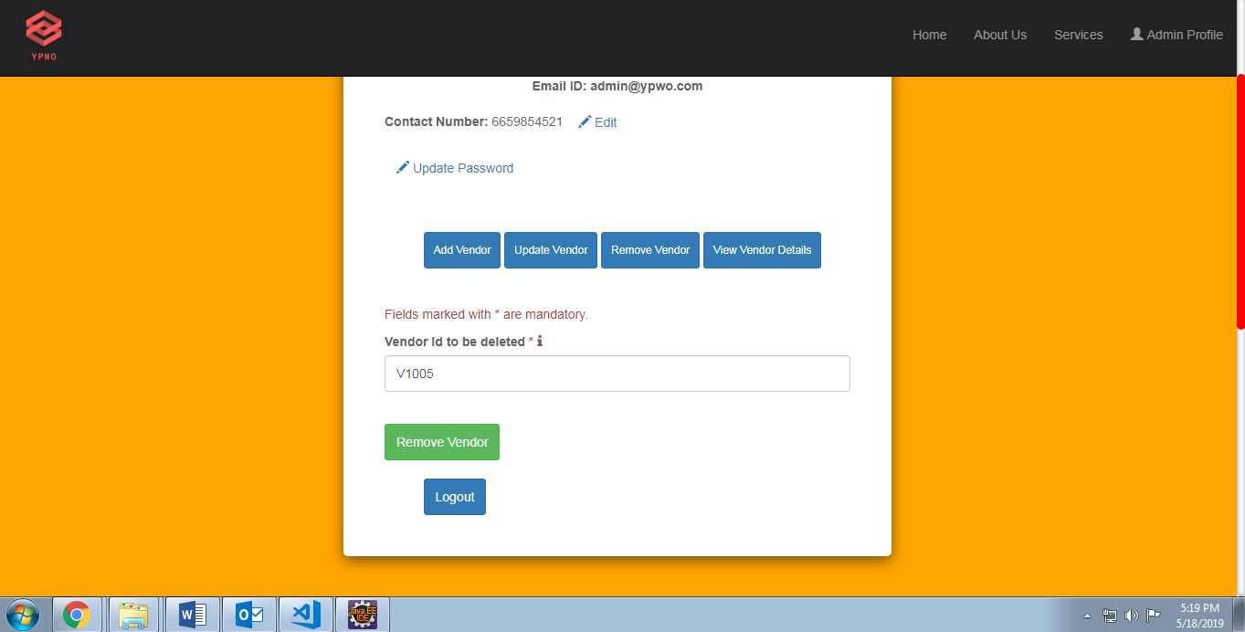

Update password

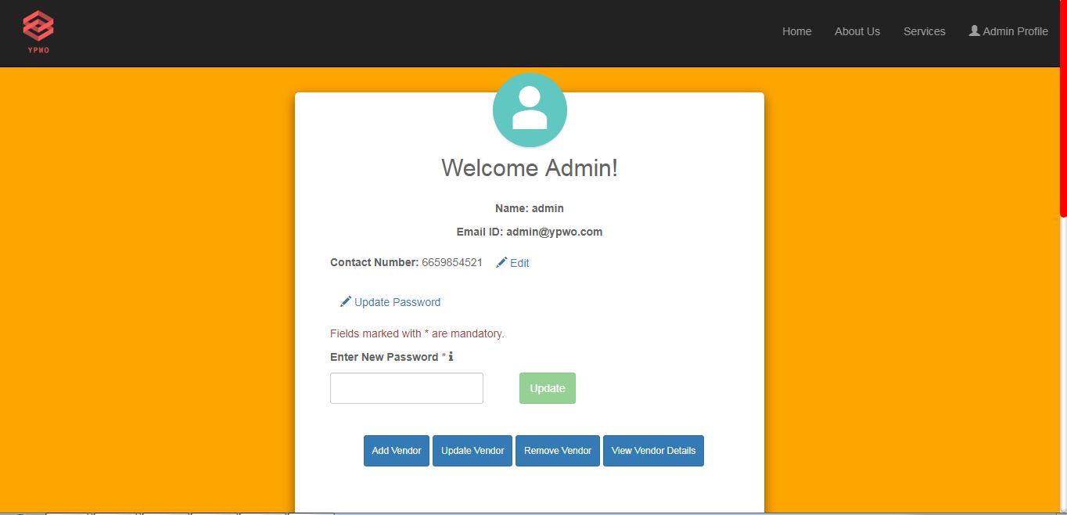

After Updations

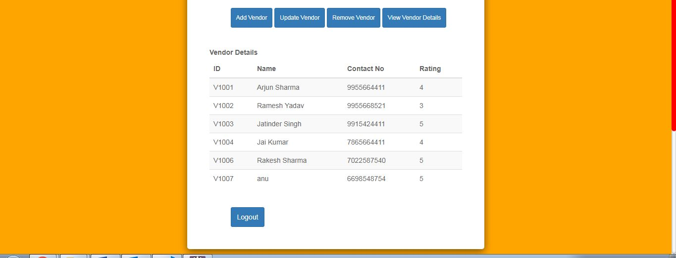

Admin service page

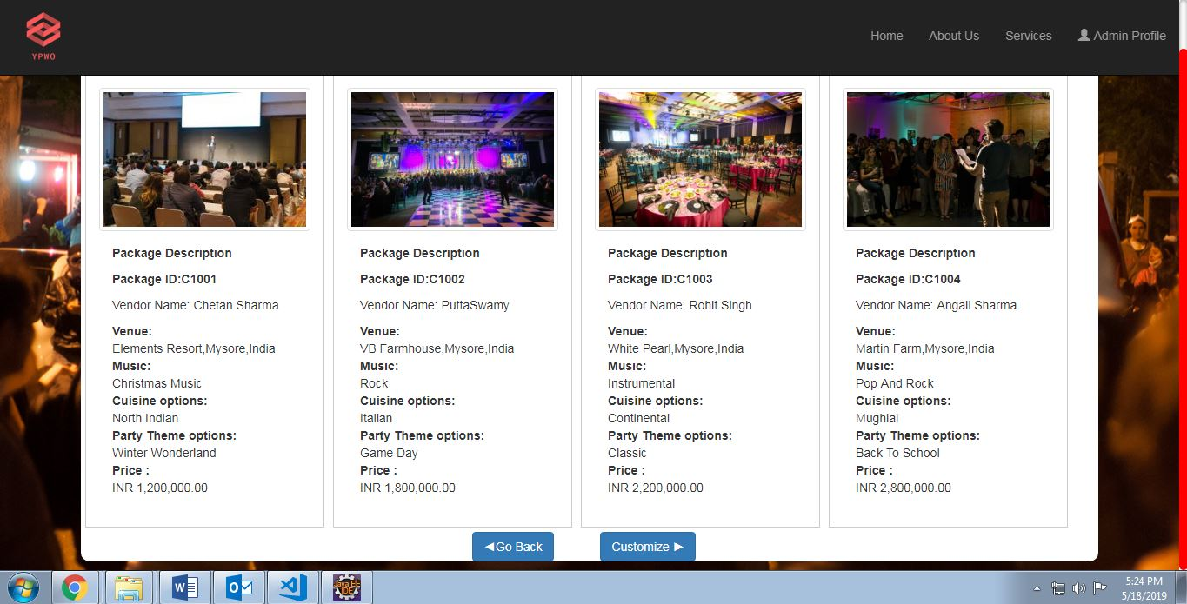

Amin logout

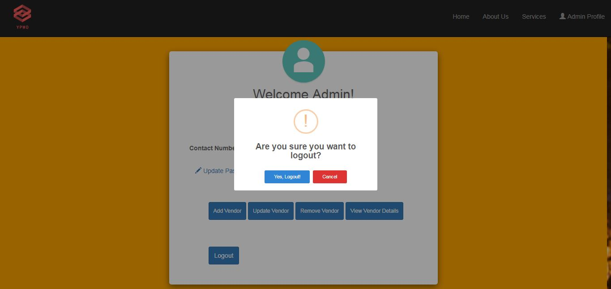

User login

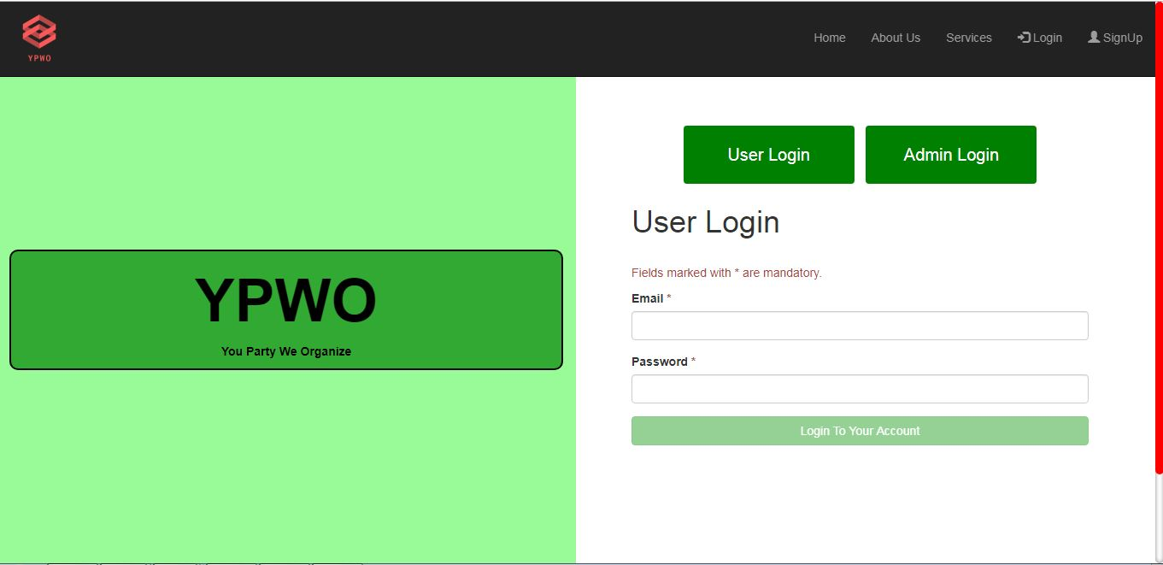

User home page

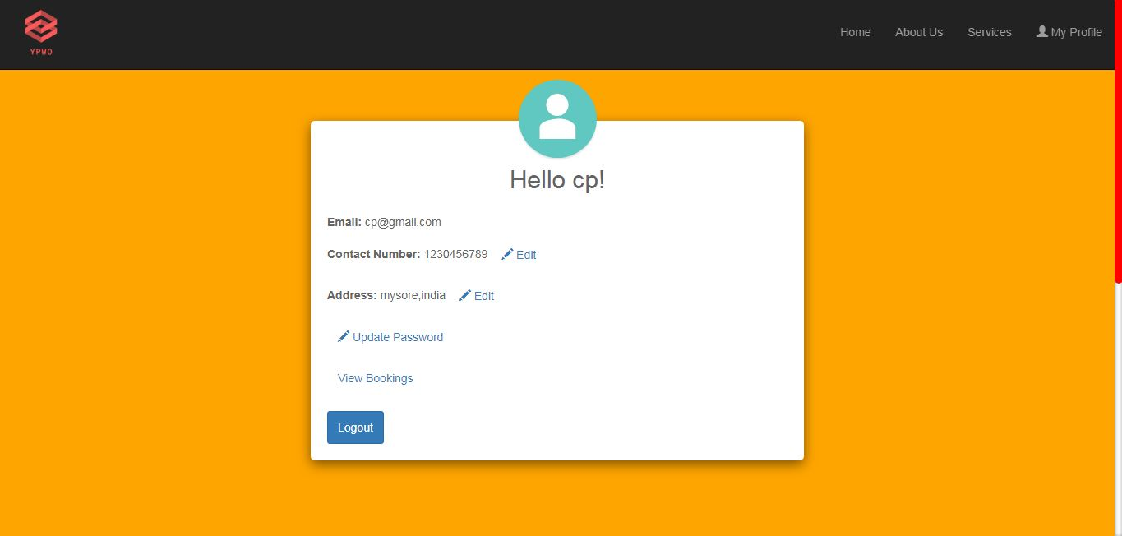

Contact edit

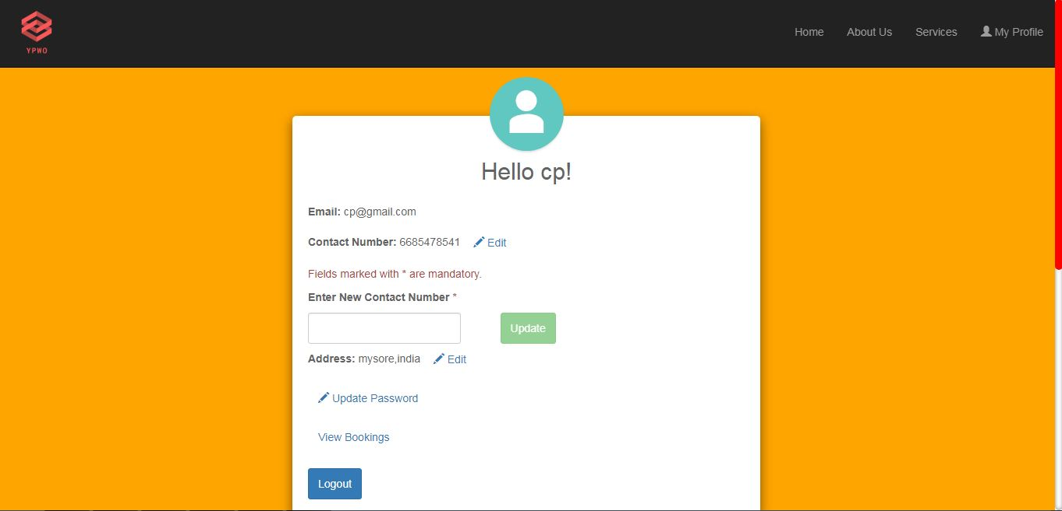

Address Edit

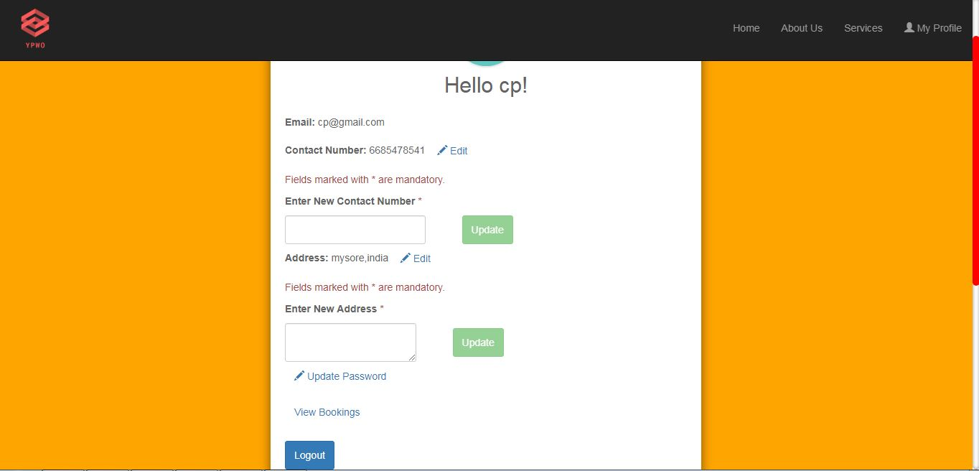

Update password

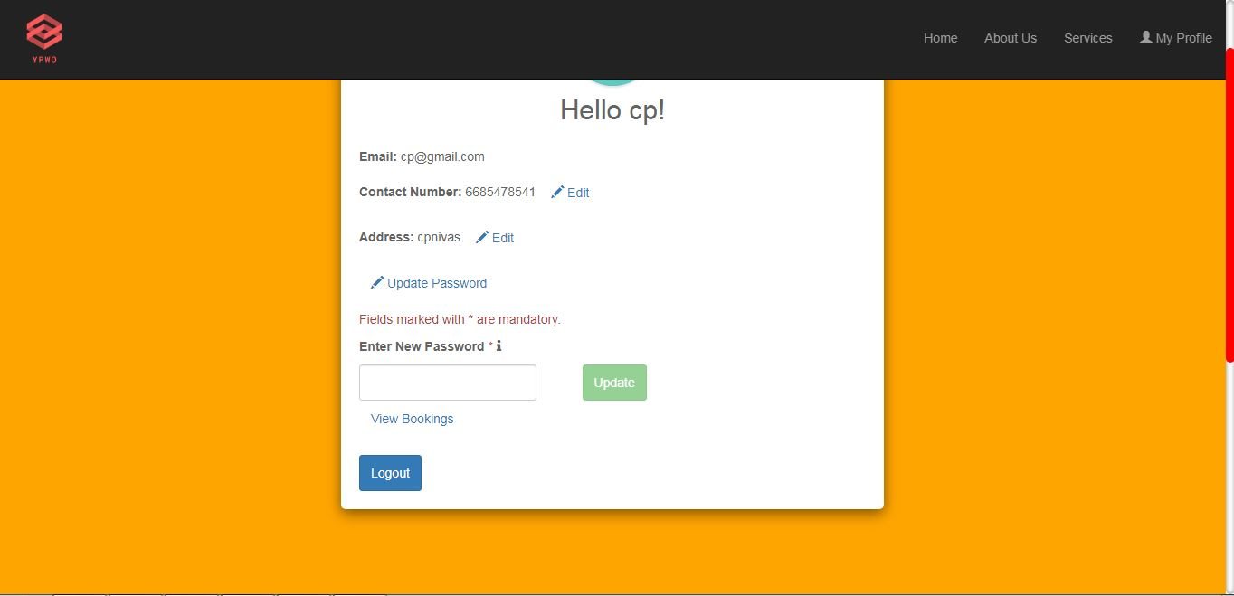

Services

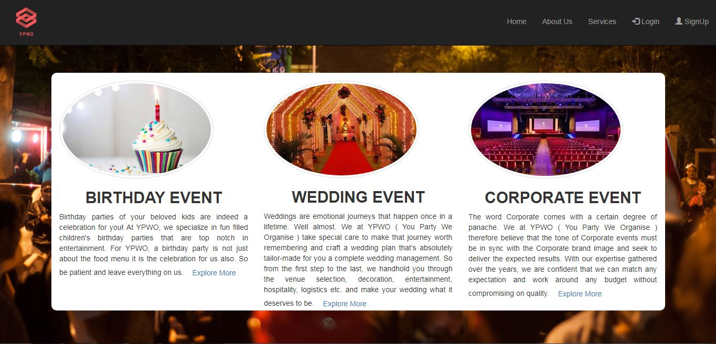

PrePackages

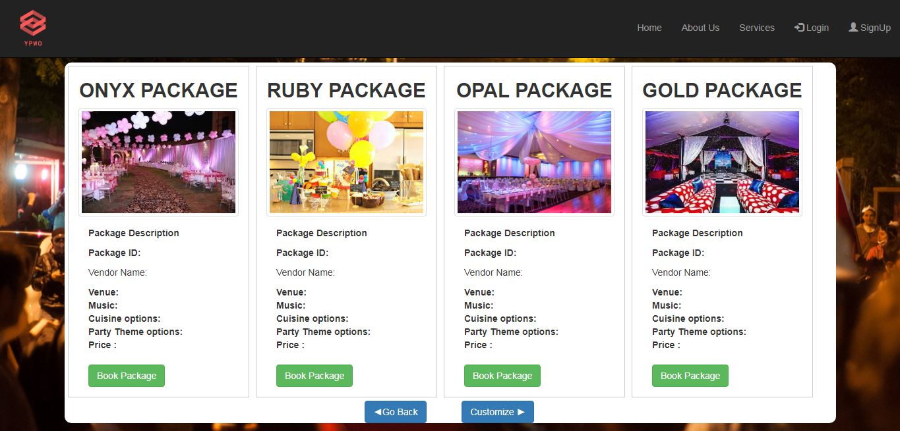

Prepackage booking

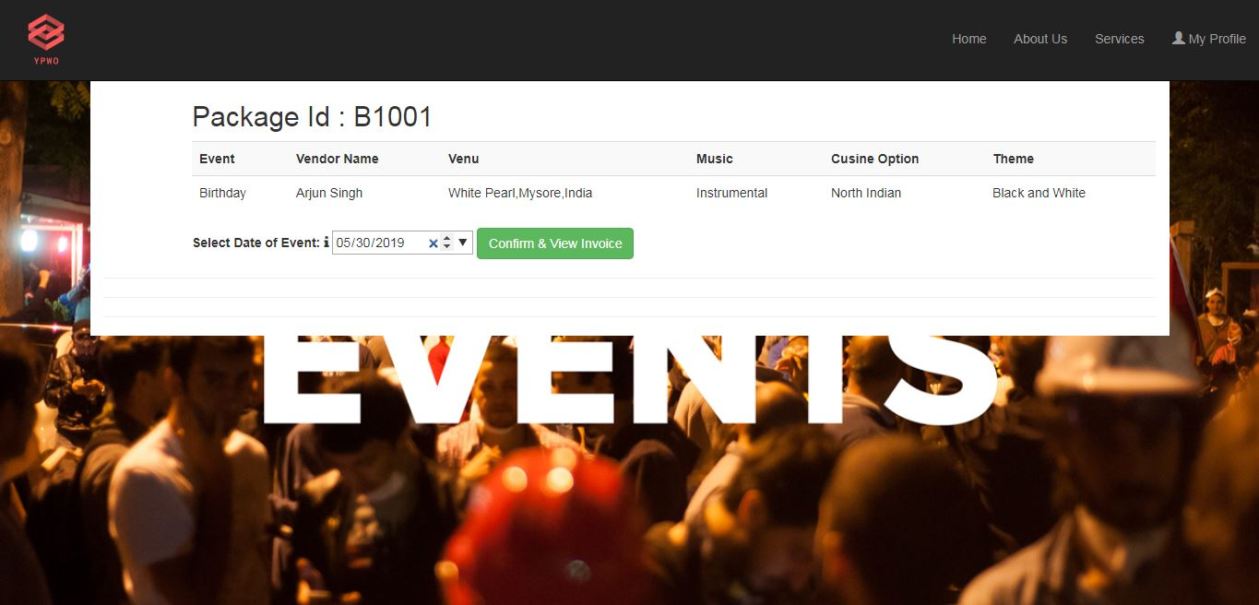

Invoice

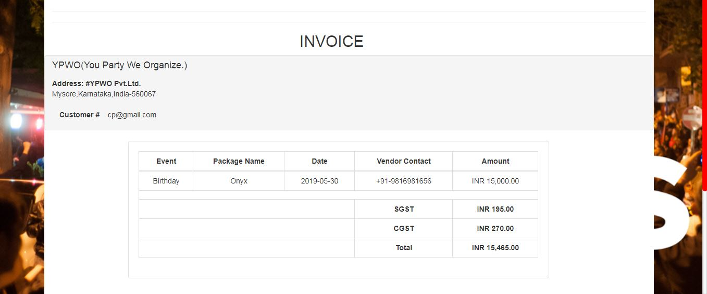

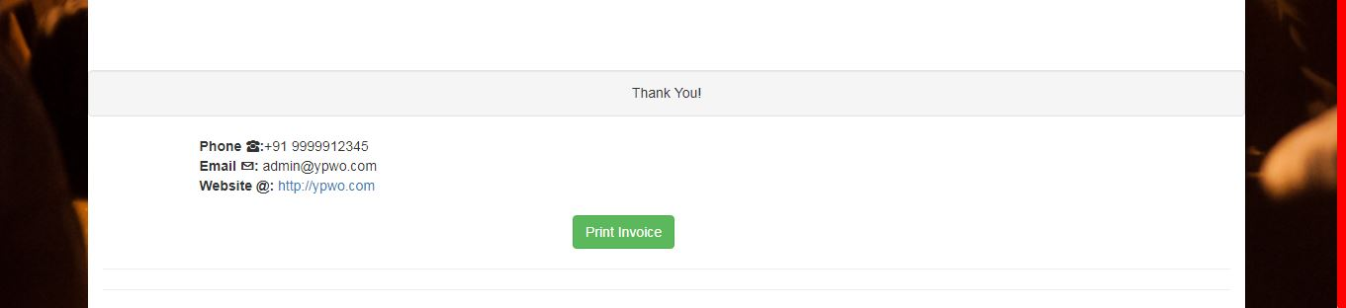

Invoice print

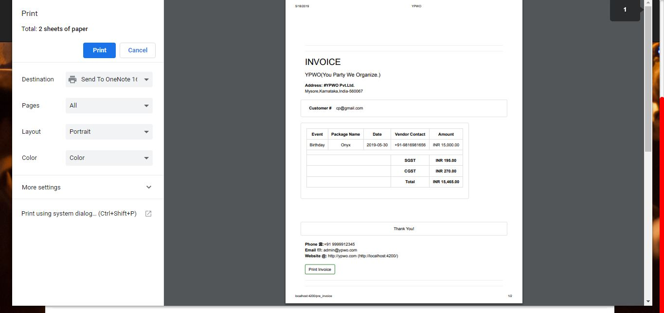

Customized Package

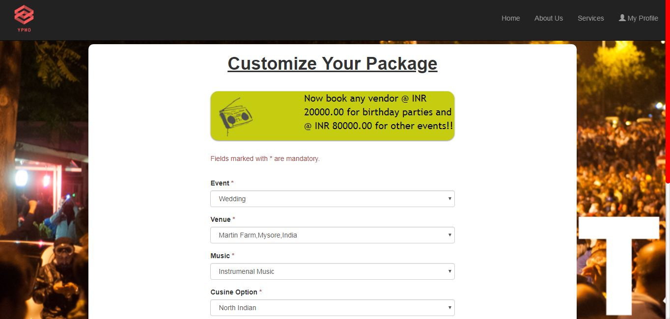

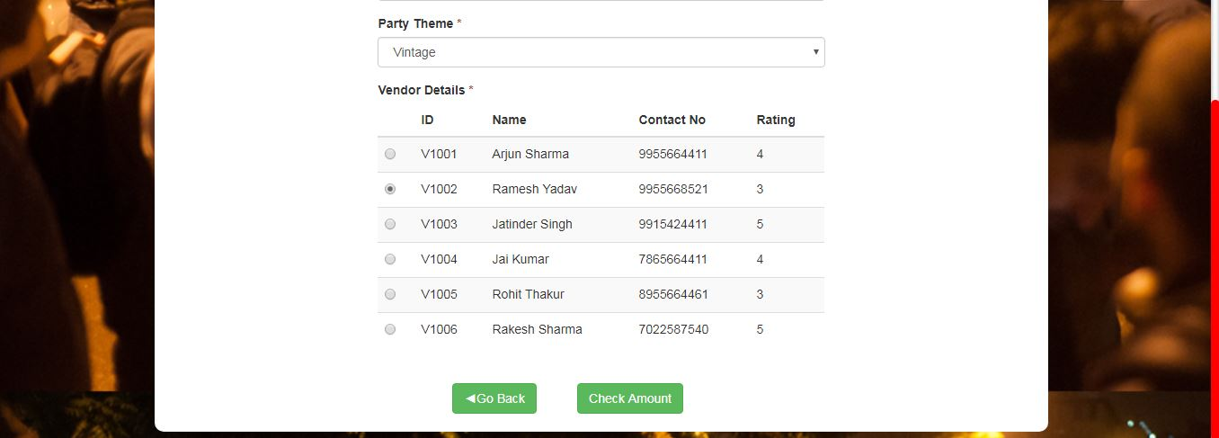

Check amount

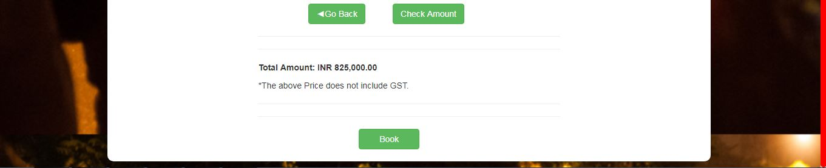

Customized booking

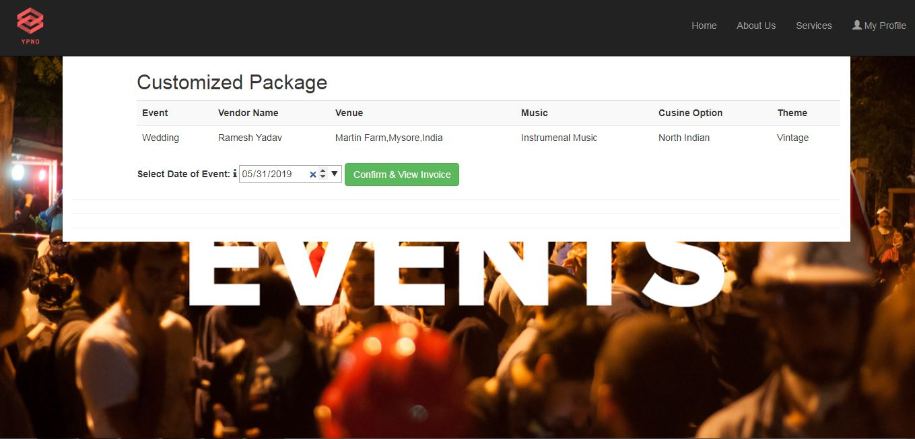

Invoice

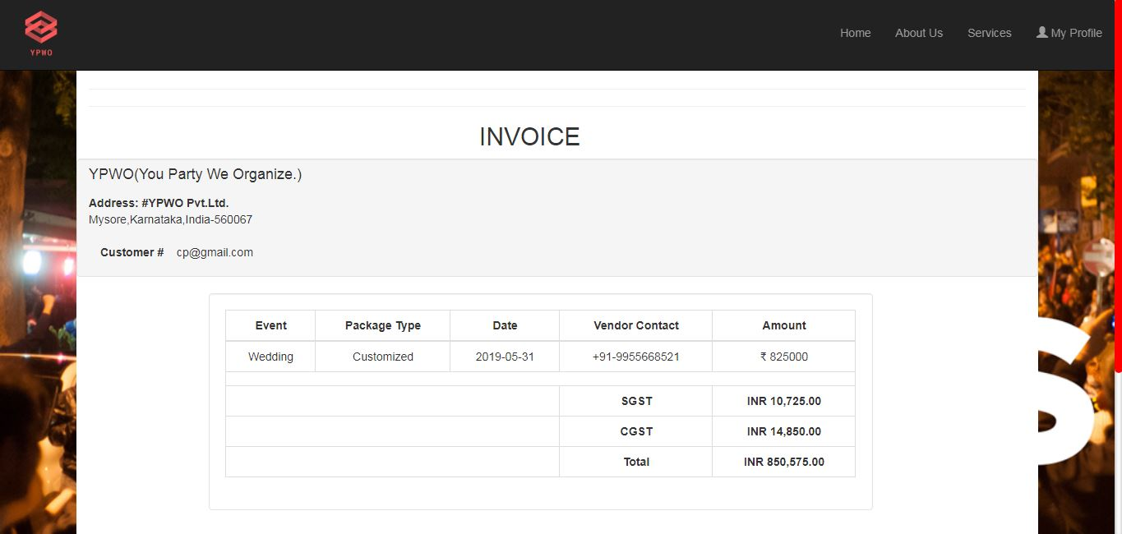

Invoice print form

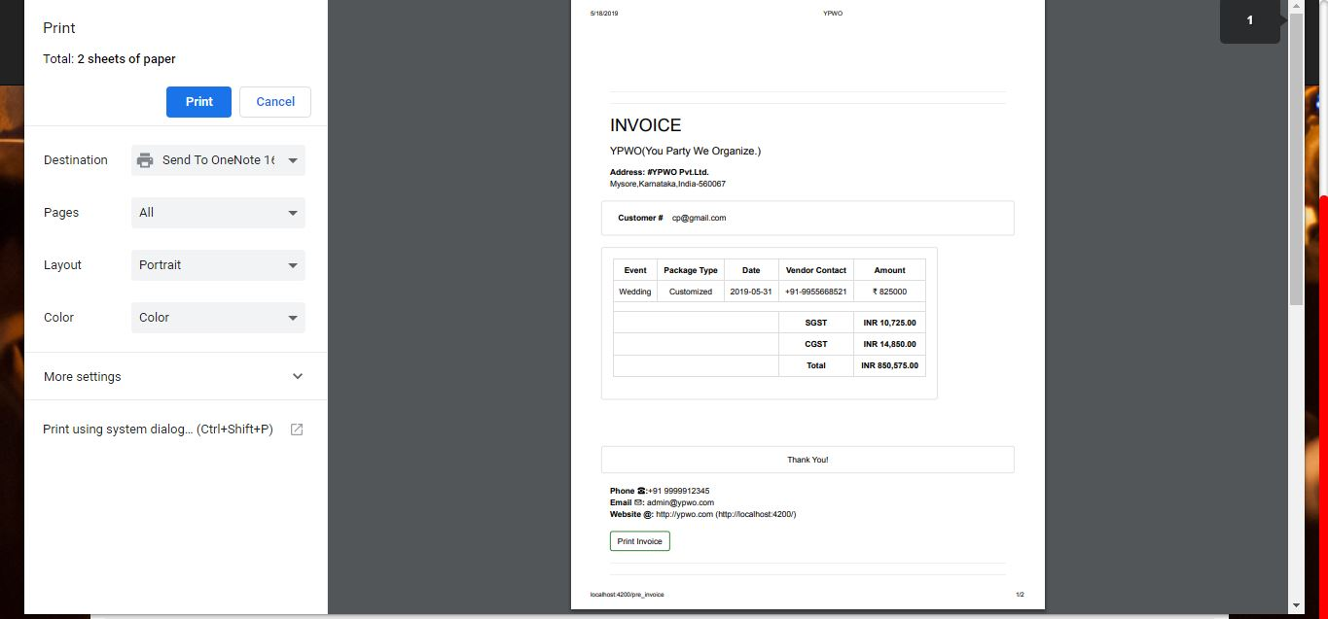

View booking

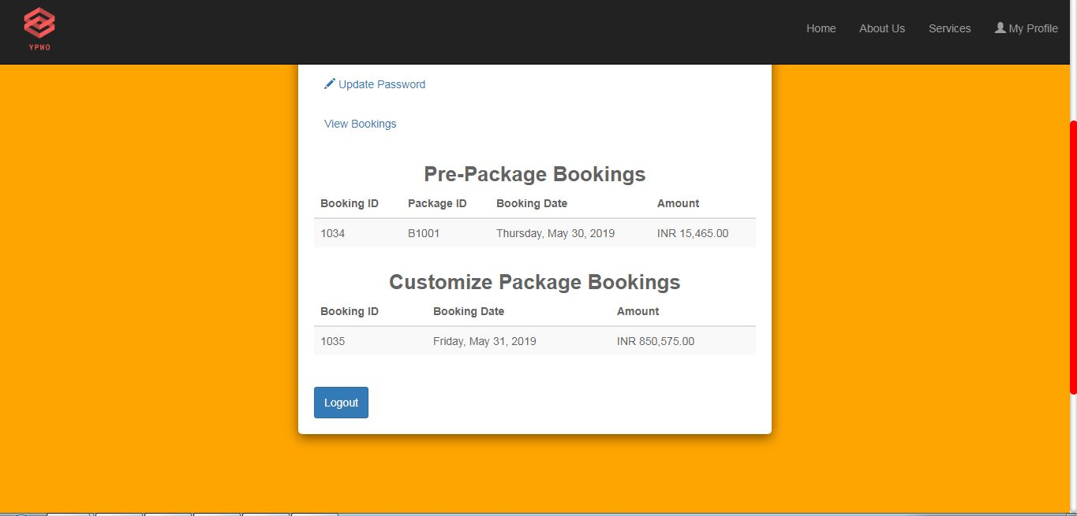

User logout

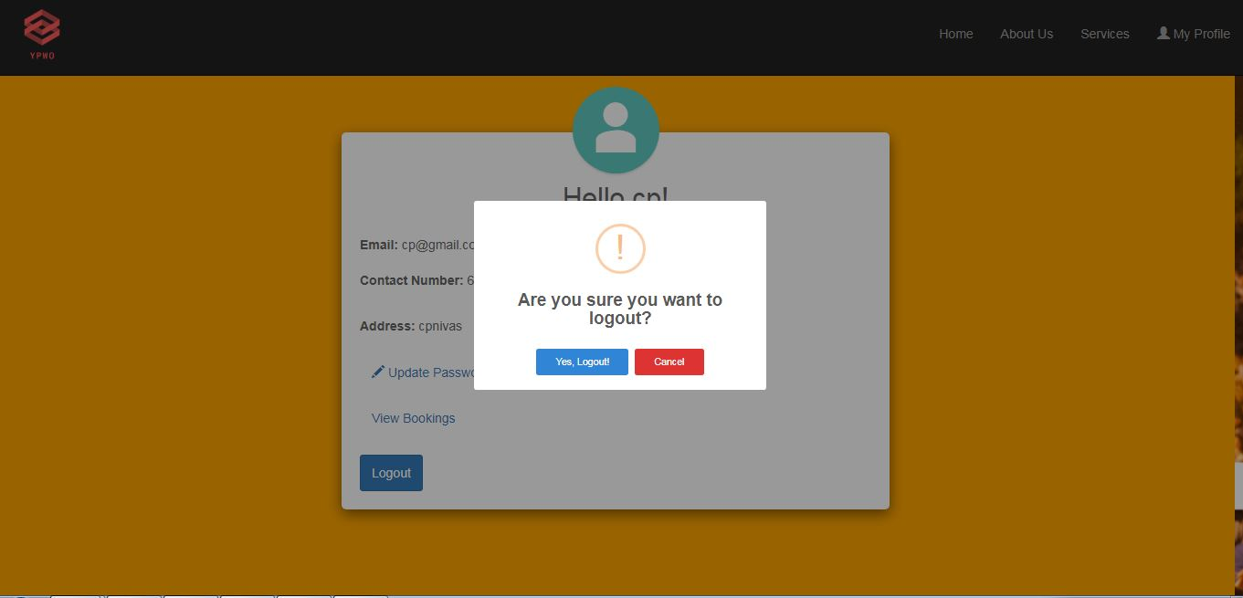

FB page

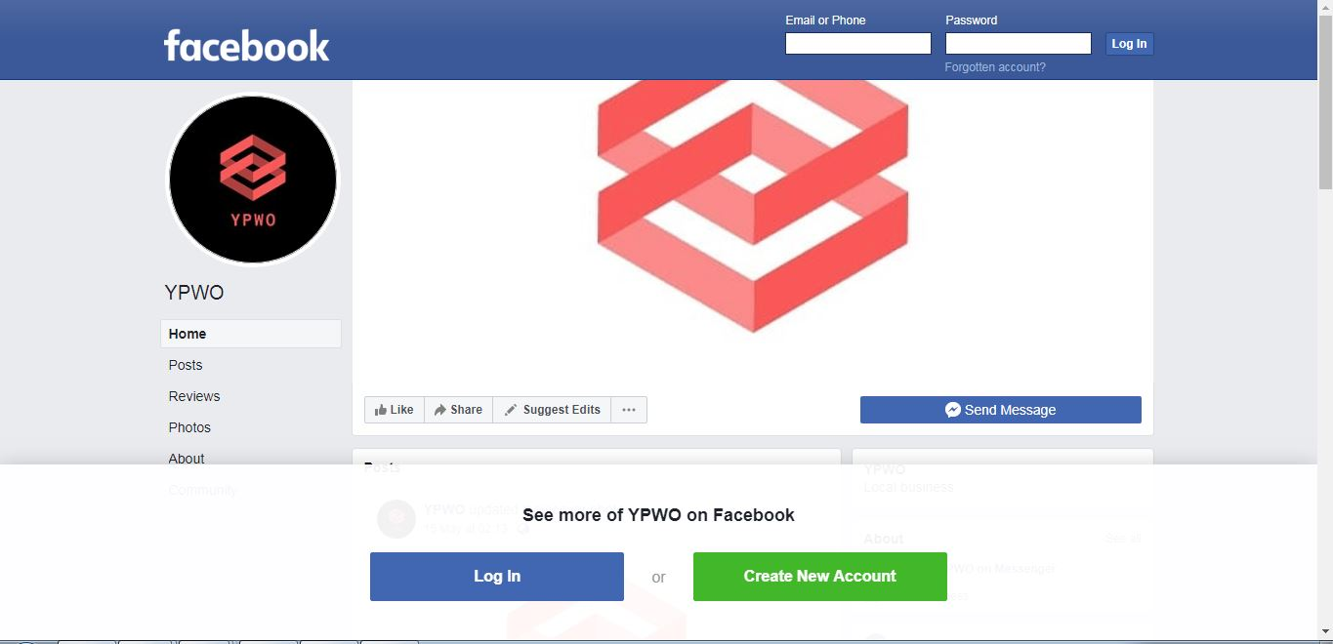

Instagram

